4/20/2019

**VENDOR LIFECYCLE MANAGEMENT SYSTEM**

( PROTOTYPE )

**Submitted by,**

**CHOND_18_JAVA3.**

**INDEX**

|  |  |  |  |
| --- | --- | --- | --- |
| **Title** | **Page No.** | **Title** | **Page No.** |
| Flow Chart of Vendor LifeCycle  Management System | 2 | RegisterServlet | 38 |
| Context File Path | 3 | Admin.html | 41 |
| Source Code | 4 | Change.html | 41 |
| Adminlogin.java | 4 | Download.html | 42 |
| ChangeStatus.java | 6 | Evaluation.html | 42 |
| VendorConnection | 7 | Home.html | 43 |
| VendorDao | 8 | Index.html | 43 |
| VendorPojo | 12 | List.html | 46 |
| EditServlet | 15 | pass.html | 48 |
| SaveServlet | 17 | Registration.html | 49 |
| SelectAll | 19 | Req.html | 52 |
| Download | 21 | Save.html | 53 |
| EvaluationServlet | 24 | Ui.html | 54 |
| Dao | 27 | Update.html | 54 |
| Login | 29 | Upload.html | 55 |
| Pass | 31 | Output Screeen Shots | 56 |
| RegServlet | 33 | Further Enhancement | 74 |
| UploadFile | 36 |  | |

**Flow Chart of Vendor LifeCycle Management System**

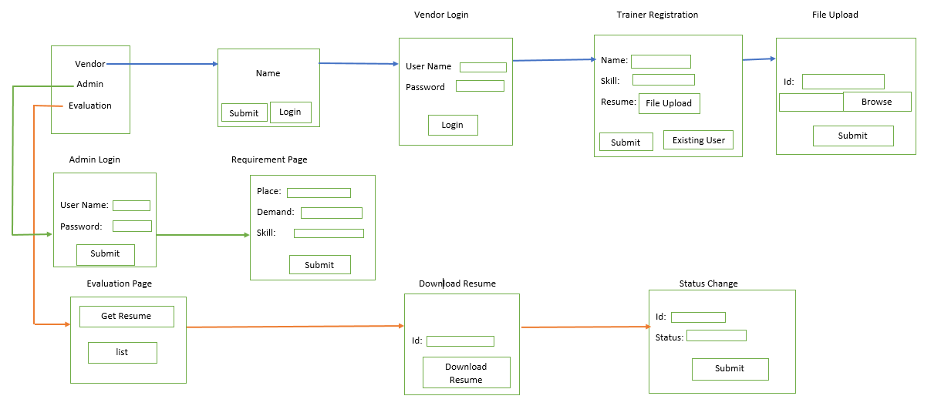

**VENDOR :-**

* The Vendor has to register if he/she is a new user, else they can login using their credentials in order to register the trainer’s detail and upload the resume of trainer’s.

**ADMIN :-**

* The Admin has to login to his/her account and should update the requirements of the trainer such as the demand of trainers, skills and the preferred location.

**EVALUATION :-**

* Evaluator has to get the details from the admin module and evaluate the trainers resume based on their requirements and then change the status of the trainer whether the trainer is selected or not.

**Context File Path :-**

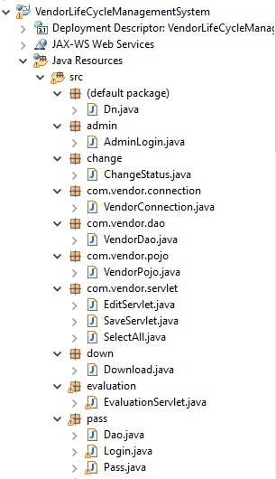

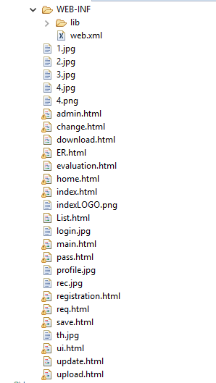

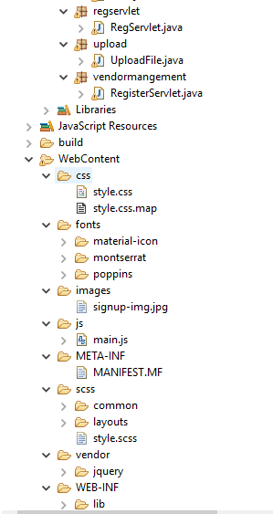

**Source Code :-**

**Package: admin**

**Class: Adminlogin.java**

package admin;

import java.io.IOException;

import java.io.PrintWriter;

import javax.servlet.RequestDispatcher;

import javax.servlet.ServletException;

import javax.servlet.annotation.WebServlet;

import javax.servlet.http.HttpServlet;

import javax.servlet.http.HttpServletRequest;

import javax.servlet.http.HttpServletResponse;

/**

* Servlet implementation class AdminLogin

*/

@WebServlet("/AdminLogin")

public class AdminLogin extends HttpServlet {

private static final long serialVersionUID = 1L;

protected void doGet(HttpServletRequest request, HttpServletResponse response)

throws ServletException, IOException {

// TODO Auto-generated method stub

String user = request.getParameter("user");

String pass = request.getParameter("pass");

PrintWriter pw = response.getWriter();

RequestDispatcher rd;

if (user.equals("admin") && pass.equals("admin"))

{

rd = request.getRequestDispatcher("req.html");

rd.forward(request, response);

} else {

pw.println("Invalid login");

rd = request.getRequestDispatcher("admin.html");

rd.include(request, response);

}

}

}

**Package: Change**

**Class: ChangeStatus.java**

**package** change;

**import** java.io.IOException;

**import** java.io.PrintWriter;

**import** javax.servlet.RequestDispatcher;

**import** javax.servlet.ServletException;

**import** javax.servlet.annotation.WebServlet;

**import** javax.servlet.http.HttpServlet;

**import** javax.servlet.http.HttpServletRequest;

**import** javax.servlet.http.HttpServletResponse;

**import** com.vendor.dao.VendorDao;

**import** com.vendor.pojo.VendorPojo;

/**

* Servlet implementation class ChangeStatus

*/

@WebServlet("/ChangeStatus")

**public** **class** ChangeStatus **extends** HttpServlet {

**private** **static** **final** **long** ***serialVersionUID*** = 1L;

**protected** **void** doGet(HttpServletRequest request, HttpServletResponse response) **throws** ServletException, IOException {

// **TODO** Auto-generated method stub

**int** id=Integer.*parseInt*(request.getParameter("id"));

String status=request.getParameter("status");

VendorPojo pj=**new** VendorPojo();

pj.setId(id);

pj.setStatus(status);

VendorDao dao=**new** VendorDao();

dao.change(pj);

PrintWriter pw=response.getWriter();

pw.println("<a href='evaluation.html'></a><br/>");

pw.println("<h1>Status changed</h1>");

RequestDispatcher rd;

rd= request.getRequestDispatcher("ER.html");

rd.include(request, response);

}

}

**Package: com.vendor.connection;**

**Class: VendorConnection**

package com.vendor.connection;

import java.sql.Connection;

import java.sql.DriverManager;

import java.sql.SQLException;

public class VendorConnection

{

static Connection con;

public static Connection get_connection()

{

try {

Class.forName("oracle.jdbc.driver.OracleDriver");

con=DriverManager.getConnection("jdbc:oracle:thin:@localhost:1521:xe","rajasekar","12345");

} catch (ClassNotFoundException e) {

// TODO Auto-generated catch block

e.printStackTrace();

} catch (SQLException e) {

// TODO Auto-generated catch block

e.printStackTrace();

}

return con;

}

}

**Package: com.vendor.dao**

**Class: VendorDao**

package com.vendor.dao;

import java.sql.Connection;

import java.sql.PreparedStatement;

import java.sql.ResultSet;

import java.sql.SQLException;

import java.sql.Statement;

import com.vendor.connection.VendorConnection;

import com.vendor.pojo.VendorPojo;

public class VendorDao

{

Connection con=VendorConnection.get_connection();

ResultSet rs;

PreparedStatement ps;

Statement st;

int x;

public int save(VendorPojo pj)

{

try {

ps=con.prepareStatement("insert into trainer_details values(?,?,?,?,?,?,?,?,?,?,?)");

ps.setInt(1, pj.getId());

ps.setString(2, pj.getName());

ps.setLong(3, pj.getContact_no());

ps.setString(4, pj.getSkill());

ps.setString(5, pj.getLocation_preference());

ps.setString(6, pj.getTraining_rex());

ps.setString(7, pj.getTex());

ps.setString(8, pj.getAvailability());

ps.setDate(9, pj.getStart_date());

ps.setDate(10, pj.getEnd_date());

ps.setString(11, pj.getStatus());

x=ps.executeUpdate();

} catch (SQLException e) {

// TODO Auto-generated catch block

e.printStackTrace();

}

return x;

}

public ResultSet list(VendorPojo pj)

{

try {

st=con.createStatement();

rs=st.executeQuery("select * from trainer_details");

} catch (SQLException e) {

// TODO Auto-generated catch block

e.printStackTrace();

}

return rs;

}

public ResultSet listreq()

{

try {

st=con.createStatement();

rs=st.executeQuery("select * from req");

} catch (SQLException e) {

// TODO Auto-generated catch block

e.printStackTrace();

}

return rs;

}

public int edit(VendorPojo pj)

{

try {

ps=con.prepareStatement("update trainer_details set name=?,contact_no=?,skill=?,location_preference=?,start_date=?,end_date=? where id=?");

ps.setString(1, pj.getName());

ps.setLong(2, pj.getContact_no());

ps.setString(3, pj.getSkill());

ps.setString(4, pj.getLocation_preference());

ps.setDate(5, pj.getStart_date());

ps.setDate(6, pj.getEnd_date());

ps.setInt(7, pj.getId());

x=ps.executeUpdate();

} catch (SQLException e) {

// TODO Auto-generated catch block

e.printStackTrace();

}

return x;

}

public void change(VendorPojo pj) {

// TODO Auto-generated method stub

try {

ps=con.prepareStatement("update trainer_details set status=? where id=?");

ps.setString(1,pj.getStatus());

ps.setInt(2, pj.getId());

x=ps.executeUpdate();

} catch (SQLException e) {

// TODO Auto-generated catch block

e.printStackTrace();

}

}

}

**Package: com.vendor.pojo**

**Class: VendorPojo**

**package** com.vendor.pojo;

**import** java.sql.Date;

**public** **class** VendorPojo {

**private** **int** id;

**private** String name;

**private** **long** contact_no;

**private** String skill;

**private** String location_preference;

**private** String training_rex;

**private** String tex;

**private** String availability;

**private** Date start_date;

**private** Date end_date;

**private** String status;

**public** VendorPojo() {

**super**();

}

**public** VendorPojo(**int** id, String name, **long** contact_no, String skill, String location_preference,

String training_rex, String tex, String availability, Date start_date, Date end_date, String status) {

**super**();

**this**.id = id;

**this**.name = name;

**this**.contact_no = contact_no;

**this**.skill = skill;

**this**.location_preference = location_preference;

**this**.training_rex = training_rex;

**this**.tex = tex;

**this**.availability = availability;

**this**.start_date = start_date;

**this**.end_date = end_date;

**this**.status = status;

}

**public** VendorPojo(String name, **long** contact_no, String skill, String location_preference, Date start_date,

Date end_date,**int** id) {

**super**();

**this**.name = name;

**this**.contact_no = contact_no;

**this**.skill = skill;

**this**.location_preference = location_preference;

**this**.start_date = start_date;

**this**.end_date = end_date;

**this**.id=id;

}

**public** **int** getId() {

**return** id;

}

**public** **void** setId(**int** id) {

**this**.id = id;

}

**public** String getName() {

**return** name;

}

**public** **void** setName(String name) {

**this**.name = name;

}

**public** **long** getContact_no() {

**return** contact_no;

}

**public** **void** setContact_no(**long** contact_no) {

**this**.contact_no = contact_no;

}

**public** String getSkill() {

**return** skill;

}

**public** **void** setSkill(String skill) {

**this**.skill = skill;

}

**public** String getLocation_preference() {

**return** location_preference;

}

**public** **void** setLocation_preference(String location_preference) {

**this**.location_preference = location_preference;

}

**public** String getTraining_rex() {

**return** training_rex;

}

**public** **void** setTraining_rex(String training_rex) {

**this**.training_rex = training_rex;

}

**public** String getTex() {

**return** tex;

}

**public** **void** setTex(String tex) {

**this**.tex = tex;

}

**public** String getAvailability() {

**return** availability;

}

**public** **void** setAvailability(String availability) {

**this**.availability = availability;

}

**public** Date getStart_date() {

**return** start_date;

}

**public** **void** setStart_date(Date start_date) {

**this**.start_date = start_date;

}

**public** Date getEnd_date() {

**return** end_date;

}

**public** **void** setEnd_date(Date end_date) {

**this**.end_date = end_date;

}

**public** String getStatus() {

**return** status;

}

**public** **void** setStatus(String status) {

**this**.status = status;

}

@Override

**public** String toString() {

**return** "VendorPojo [id=" + id + ", name=" + name + ", contact_no=" + contact_no + ", skill=" + skill

+ ", location_preference=" + location_preference + ", training_rex=" + training_rex + ", tex=" + tex

+ ", availability=" + availability + ", start_date=" + start_date + ", end_date=" + end_date

+ ", status=" + status + "]";

}

}

**Package: com.vendor.servlet**

**Class: EditServlet**

package com.vendor.servlet;

import java.io.IOException;

import java.io.PrintWriter;

import java.text.ParseException;

import java.text.SimpleDateFormat;

import javax.servlet.ServletException;

import javax.servlet.annotation.WebServlet;

import javax.servlet.http.HttpServlet;

import javax.servlet.http.HttpServletRequest;

import javax.servlet.http.HttpServletResponse;

import com.vendor.dao.VendorDao;

import com.vendor.pojo.VendorPojo;

@WebServlet("/EditServlet")

public class EditServlet extends HttpServlet {

private static final long serialVersionUID = 1L;

protected void doPost(HttpServletRequest request, HttpServletResponse response) throws ServletException, IOException {

PrintWriter pw = response.getWriter();

pw.println("<h3>edit details:</h3>");

int id=Integer.parseInt(request.getParameter("id"));

String name=request.getParameter("name");

Long contact_no=Long.parseLong(request.getParameter("contact_no"));

String skill=request.getParameter("skill");

String location_preference=request.getParameter("location_preference");

java.util.Date start_date;

try {

start_date = new SimpleDateFormat("dd-MMM-yyyy").parse(request.getParameter("start_date"));

java.sql.Date start_date1=new java.sql.Date(start_date.getTime());

java.util.Date end_date=new SimpleDateFormat("dd-MMM-yyyy").parse(request.getParameter("end_date"));

java.sql.Date end_date1=new java.sql.Date(end_date.getTime());

VendorPojo pj=new VendorPojo(name,contact_no,skill,location_preference,start_date1,end_date1,id);

VendorDao dao=new VendorDao();

int x=dao.edit(pj);

if(x!=0)

{

pw.print("<h1>Record Updated successfully!</h1>");

request.getRequestDispatcher("update.html").include(request,response);

}

else

{

pw.println("Sorry! unable to  update a record");

}

} catch (ParseException e) {

e.printStackTrace();

}

}

}

**Package: com.vendor.servlet**

**Class: SaveServlet**

package com.vendor.servlet;

import java.io.IOException;

import java.io.PrintWriter;

import java.text.ParseException;

import java.text.SimpleDateFormat;

import javax.servlet.ServletException;

import javax.servlet.annotation.WebServlet;

import javax.servlet.http.HttpServlet;

import javax.servlet.http.HttpServletRequest;

import javax.servlet.http.HttpServletResponse;

import com.vendor.dao.VendorDao;

import com.vendor.pojo.VendorPojo;

@WebServlet("/SaveServlet")

public class SaveServlet extends HttpServlet {

private static final long serialVersionUID = 1L;

protected void doPost(HttpServletRequest request, HttpServletResponse response) throws ServletException, IOException {

PrintWriter pw=response.getWriter();

int id=Integer.parseInt(request.getParameter("id"));

String name=request.getParameter("name");

Long contact_no=Long.parseLong(request.getParameter("contact_no"));

String skill=request.getParameter("skill");

String location_preference=request.getParameter("location_preference");

String training_rex=request.getParameter("training_rex");

String tex=request.getParameter("tex");

String availability=request.getParameter("availability");

String status=request.getParameter("status");

try {

java.util.Date start_date=new SimpleDateFormat("dd-MMM-yyyy").parse(request.getParameter("start_date"));

java.sql.Date start_date1=new java.sql.Date(start_date.getTime());

java.util.Date end_date=new SimpleDateFormat("dd-MMM-yyyy").parse(request.getParameter("end_date"));

java.sql.Date end_date1=new java.sql.Date(end_date.getTime());

VendorDao dao=new VendorDao();

VendorPojo pj=new VendorPojo(id,name,contact_no,skill,location_preference,training_rex,tex,availability,start_date1,end_date1,status);

int x=dao.save(pj);

if(x!=0)

{

pw.print("<h1>Record saved successfully!</h1>");

request.getRequestDispatcher("save.html").include(request,response);

}

else {

pw.println("Sorry! unable to save record");

}

} catch (ParseException e) {

// TODO Auto-generated catch block

e.printStackTrace();

}

}

}

**Package: com.vendor.servlet**

**Class: SelectAll**

package com.vendor.servlet;

import java.io.IOException;

import java.io.PrintWriter;

import java.sql.ResultSet;

import java.sql.SQLException;

import javax.servlet.ServletException;

import javax.servlet.annotation.WebServlet;

import javax.servlet.http.HttpServlet;

import javax.servlet.http.HttpServletRequest;

import javax.servlet.http.HttpServletResponse;

import com.vendor.dao.VendorDao;

import com.vendor.pojo.VendorPojo;

@WebServlet("/SelectAll")

public class SelectAll extends HttpServlet {

private static final long serialVersionUID = 1L;

protected void doPost(HttpServletRequest request, HttpServletResponse response)

throws ServletException, IOException {

PrintWriter pw = response.getWriter();

VendorDao dao = new VendorDao();

VendorPojo pj = new VendorPojo();

ResultSet rs = dao.list(pj);

pw.println("<html><body>");

pw.println("<table border=1>");

pw.println(

"<tr><th>ID</th><th>Name</th><th>Contact No</th><th>skill</th><th>location preference</th><th>training rex</th><th>tex</th><th>availability</th><th>start date</th><th>end date</th><th>status</th><th>Edit</th></tr>");

try {

while (rs.next()) {

pw.println("<tr><td>" + rs.getInt(1) + "</td><td>" + rs.getString(2) + "</td><td>" + rs.getLong(3)

+ "</td><td>" + rs.getString(4) + "</td><td>" + rs.getString(5) + "</td><td>" + rs.getString(6)

+ "</td><td>" + rs.getString(7) + "</td><td>" + rs.getString(8) + "</td><td>" + rs.getDate(9)

+ "</td><td>" + rs.getDate(10) + "</td><td>" + rs.getString(11) + "</td><td><a href='update.html'>Edit</a></td></tr>");

}

pw.println("</table>");

pw.println("</body></html>");

} catch (SQLException e) {

e.printStackTrace();

}

}

}

**Package: down**

**Class: Download**

package down;

import java.io.FileOutputStream;

import java.io.IOException;

import java.io.PrintWriter;

import java.sql.Blob;

import java.sql.Connection;

import java.sql.DriverManager;

import java.sql.PreparedStatement;

import java.sql.ResultSet;

import javax.servlet.ServletException;

import javax.servlet.annotation.WebServlet;

import javax.servlet.http.HttpServlet;

import javax.servlet.http.HttpServletRequest;

import javax.servlet.http.HttpServletResponse;

/**

* Servlet implementation class Download

*/

@WebServlet("/Download")

public class Download extends HttpServlet {

private static final long serialVersionUID = 1L;

protected void doGet(HttpServletRequest request, HttpServletResponse response) throws ServletException, IOException {

// TODO Auto-generated method stub

String id=request.getParameter("id");

try {

Class.forName("oracle.jdbc.driver.OracleDriver");

Connection con = DriverManager.getConnection("jdbc:oracle:thin:@localhost:1521:xe", "Rajasekar", "12345");

PreparedStatement ps = con.prepareStatement("select * from imgtable where name=?");

ps.setString(1, id);

ResultSet rs = ps.executeQuery();

if (rs.next()) {// now on 1st row

Blob b = rs.getBlob(2);// 2 means 2nd column data

byte barr[] = b.getBytes(1, (int) b.length());// 1 means first

// image

FileOutputStream fout = new FileOutputStream("C:\\Users\\Training\\Desktop\\test\\in.doc");

fout.write(barr);

fout.close();

} // end of if

System.out.println("ok");

con.close();

PrintWriter pw=response.getWriter();

pw.println("<html>");

pw.println("<body background='1.jpg'>");

pw.println("<center>");

pw.println("<h1><font color='white'>C:\\Users\\Training\\Desktop\\test\\in.doc</font></h1><br/>");

pw.println("<a href=download.html>CLICK HERE TO DOWNLOAD THE DOCUMENT</a><br/><br/>");

pw.println("<a href='change.html'>Status change</a><br/>");

pw.println("</center>");

pw.println("<br/>");

pw.println("</body>");

pw.println("</html>");

} catch (Exception e) {

e.printStackTrace();

}

}

}

**Package: evaluation**

**Class: EvaluationServlet**

package evaluation;

import java.io.IOException;

import java.io.PrintWriter;

import java.sql.Connection;

import java.sql.PreparedStatement;

import java.sql.ResultSet;

import java.sql.SQLException;

import java.sql.Statement;

import javax.servlet.ServletException;

import javax.servlet.annotation.WebServlet;

import javax.servlet.http.HttpServlet;

import javax.servlet.http.HttpServletRequest;

import javax.servlet.http.HttpServletResponse;

import com.vendor.connection.VendorConnection;

import com.vendor.dao.VendorDao;

import com.vendor.pojo.VendorPojo;

/**

* Servlet implementation class EvaluationServlet

*/

@WebServlet("/EvaluationServlet")

public class EvaluationServlet extends HttpServlet {

private static final long serialVersionUID = 1L;

/**

* @see HttpServlet#HttpServlet()

*/

public EvaluationServlet() {

super();

// TODO Auto-generated constructor stub

}

/**

* @see HttpServlet#doGet(HttpServletRequest request, HttpServletResponse response)

*/

protected void doGet(HttpServletRequest request, HttpServletResponse response) throws ServletException, IOException {

try

{ Connection con=VendorConnection.get_connection();

PrintWriter pw = response.getWriter();

ResultSet rs;

PreparedStatement ps;

Statement st;

st=con.createStatement();

rs=st.executeQuery("select * from req");

pw.println("<html><body>");

pw.println("<table border=1>");

pw.println(

"<tr><th>PLACE</th><th>Number Of Vacancies</th><th>Stream</th></tr>");

while (rs.next()) {

pw.println("<tr><td>" + rs.getString(1) + "</td><td>" + rs.getString(2) + "</td><td>" + rs.getString(3)+"</td></tr>");

}

pw.println("</table>");

pw.println("<a href='List.html'>List</a><br/>");

pw.println("<br/>");

pw.println("<a href='ER.html'>Evaluate resume</a>");

pw.println("</body></html>");

} catch (SQLException e) {

e.printStackTrace();

}

}

}

**Package: pass**

**Class: Dao**

package pass;

import java.sql.Connection;

import java.sql.DriverManager;

import java.sql.PreparedStatement;

import java.sql.ResultSet;

import java.sql.SQLException;

public class Dao {

boolean check(int uname, String cp) {

boolean st=false;

try {

Class.forName("oracle.jdbc.driver.OracleDriver");

Connection con=DriverManager.getConnection("jdbc:oracle:thin:@localhost:1521:XE:","Rajasekar","12345");

PreparedStatement ps=con.prepareStatement("select password from vendormanagement where userid=?");

ps.setInt(1, uname);

ResultSet rs=ps.executeQuery();

st=rs.next();

} catch (ClassNotFoundException e) {

// TODO Auto-generated catch block

e.printStackTrace();

} catch (SQLException e) {

// TODO Auto-generated catch block

e.printStackTrace();

}

return st;

}

public int change(String np) {

// TODO Auto-generated method stub

int st=0;

try{

Class.forName("oracle.jdbc.driver.OracleDriver");

Connection con=DriverManager.getConnection("jdbc:oracle:thin:@localhost:1521:XE:","varsha","varsha");

PreparedStatement ps=con.prepareStatement("update abc set pass=? where pass=pass");

ps.setString(1, np);

st=ps.executeUpdate();

} catch (ClassNotFoundException e) {

// TODO Auto-generated catch block

e.printStackTrace();

} catch (SQLException e) {

// TODO Auto-generated catch block

e.printStackTrace();

}

return st;

}

}

**Package: pass**

**Class: Login**

package pass;

import java.io.IOException;

import java.io.PrintWriter;

import javax.servlet.RequestDispatcher;

import javax.servlet.ServletException;

import javax.servlet.annotation.WebServlet;

import javax.servlet.http.HttpServlet;

import javax.servlet.http.HttpServletRequest;

import javax.servlet.http.HttpServletResponse;

/**

* Servlet implementation class Login

*/

@WebServlet("/Login")

public class Login extends HttpServlet {

private static final long serialVersionUID = 1L;

protected void doGet(HttpServletRequest request, HttpServletResponse response) throws ServletException, IOException {

// TODO Auto-generated method stub

int uname=Integer.parseInt(request.getParameter("uname"));

String cp=request.getParameter("curr");

Dao d=new Dao();

boolean status =d.check(uname,cp);

RequestDispatcher rd;

PrintWriter pw=response.getWriter();

if(status)

{pw.println("<html>");

pw.println("<body>");

pw.print("<form action='SelectAll' method='post'>");

pw.print( "<input type='submit' value='Submit'>"

+ "</form>");

}

}

}

**Package: pass**

**Class:Pass**

package pass;

import java.io.IOException;

import java.io.PrintWriter;

import javax.servlet.RequestDispatcher;

import javax.servlet.ServletException;

import javax.servlet.annotation.WebServlet;

import javax.servlet.http.HttpServlet;

import javax.servlet.http.HttpServletRequest;

import javax.servlet.http.HttpServletResponse;

/**

* Servlet implementation class Pass

*/

@WebServlet("/Pass")

public class Pass extends HttpServlet {

private static final long serialVersionUID = 1L;

protected void doGet(HttpServletRequest request, HttpServletResponse response) throws ServletException, IOException {

int uname=Integer.parseInt(request.getParameter("uname"));

String cp=request.getParameter("curr");

String np=request.getParameter("np");

String rp=request.getParameter("rp");

Dao d=new Dao();

boolean status =d.check(uname,cp);

RequestDispatcher rd;

PrintWriter pw=response.getWriter();

if(status)

{

if(np.equals(rp)){

d.change(np);

rd=request.getRequestDispatcher("ui.html");

rd.include(request, response);

}

}

}

}

**Package: regservlet**

**Class: RegServlet**

package regservlet;

import java.io.IOException;

import java.io.PrintWriter;

import java.sql.Connection;

import java.sql.PreparedStatement;

import java.sql.ResultSet;

import java.sql.SQLException;

import java.sql.Statement;

import javax.servlet.ServletException;

import javax.servlet.annotation.WebServlet;

import javax.servlet.http.HttpServlet;

import javax.servlet.http.HttpServletRequest;

import javax.servlet.http.HttpServletResponse;

import com.vendor.connection.VendorConnection;

import com.vendor.pojo.VendorPojo;

@WebServlet("/RegServlet")

public class RegServlet extends HttpServlet {

private static final long serialVersionUID = 1L;

protected void doGet(HttpServletRequest request, HttpServletResponse response) throws ServletException, IOException {

response.setContentType("text/html");

Connection con=VendorConnection.get_connection();

PrintWriter pw=response.getWriter();

String place=request.getParameter("place");

String nov=request.getParameter("nov");

String stream=request.getParameter("stream");

ResultSet rs;

PreparedStatement ps;

Statement st;

try {

ps=con.prepareStatement("insert into req values(?,?,?)");

ps.setString(1, place);

ps.setString(2, nov);

ps.setString(3, stream);

ps.executeUpdate();

} catch (SQLException e) {

// TODO Auto-generated catch block

e.printStackTrace();

}

pw.println("<html>");

pw.println("<body>");

pw.println("<br/>");

pw.println("PLACE DETAIL IS :"+place);

pw.println("<br/>");

pw.println("NUMBER OF VACANCY IS :"+nov);

pw.println("<br/>");

pw.println("STREAM IS :"+stream);

pw.println("<br/>");

pw.println("<a href='List.html'>List</a><br/>");

pw.println("<br/>");

pw.println("<a href='ER.html'>Evaluate resume</a>");

pw.println("</html>");

pw.println("</body>");

}

protected void doPost(HttpServletRequest request, HttpServletResponse response) throws ServletException, IOException {

// TODO Auto-generated method stub

doGet(request, response);

}

}

**Package: upload**

**Class: UploadFile**

package upload;

import java.io.FileInputStream;

import java.io.IOException;

import java.io.InputStream;

import java.io.PrintWriter;

import java.sql.Connection;

import java.sql.PreparedStatement;

import java.sql.SQLException;

import javax.servlet.RequestDispatcher;

import javax.servlet.ServletException;

import javax.servlet.annotation.WebServlet;

import javax.servlet.http.HttpServlet;

import javax.servlet.http.HttpServletRequest;

import javax.servlet.http.HttpServletResponse;

import javax.servlet.http.Part;

import com.vendor.connection.VendorConnection;

/**

* Servlet implementation class UploadFile

*/

@WebServlet("/UploadFile")

public class UploadFile extends HttpServlet {

private static final long serialVersionUID = 1L;

InputStream ip=null;

Connection con=VendorConnection.get_connection();

protected void doGet(HttpServletRequest request, HttpServletResponse response) throws ServletException, IOException {

int id=Integer.parseInt(request.getParameter("id"));

String s=request.getParameter("browse");

System.out.println(s);

//Part fil=request.getPart("browse");

//System.out.println(fil);

//ip=fil.getInputStream();

//System.out.println(ip);

try {

PreparedStatement ps = con.prepareStatement("insert into imgtable values(?,?)");

ps.setInt(1, id);

FileInputStream fin = new FileInputStream(s);

ps.setBinaryStream(2, fin, fin.available());

ps.executeUpdate();

PrintWriter pw=response.getWriter();

pw.println("<h1>Resume Uploaded</h1>");

RequestDispatcher rd;

rd= request.getRequestDispatcher("save.html");

rd.include(request, response);

} catch (SQLException e) {

// TODO Auto-generated catch block

e.printStackTrace();

} }

}

**Package: vendormangement**

**Class: RegisterServlet**

package vendormangement;

import java.io.IOException;

import java.io.PrintWriter;

import java.sql.Connection;

import java.sql.DriverManager;

import java.sql.PreparedStatement;

import java.sql.SQLException;

import javax.servlet.ServletConfig;

import javax.servlet.ServletException;

import javax.servlet.annotation.WebServlet;

import javax.servlet.http.HttpServlet;

import javax.servlet.http.HttpServletRequest;

import javax.servlet.http.HttpServletResponse;

import com.vendor.connection.VendorConnection;

@WebServlet("/RegisterServlet")

public class RegisterServlet extends HttpServlet {

private static final long serialVersionUID = 1L;

@Override

public void init(ServletConfig config) throws ServletException {

super.init(config);

}

/** Process the HTTP Get request */

@Override

public void doPost(HttpServletRequest req, HttpServletResponse res) throws ServletException, IOException {

Connection con=VendorConnection.get_connection();

res.setContentType("text/html");

PrintWriter out = res.getWriter();

// get the variables entered in the form

String name = req.getParameter("name");

int userid = Integer.parseInt(req.getParameter("userid"));

String password = req.getParameter("password");

String Email = req.getParameter("Email");

int phone = Integer.parseInt(req.getParameter("Phone"));

String vname = req.getParameter("vname");

String spocname = req.getParameter("spocname");

int vphone = Integer.parseInt(req.getParameter("vPhone"));

String sql = "insert into vendormanagement values (?,?,?,?,?,?,?,?)";

PreparedStatement pst;

try {

pst = con.prepareStatement(sql);

pst.setString(1, name);

pst.setInt(2, userid);

pst.setString(3, password);

pst.setString(4, Email);

pst.setInt(5, phone);

pst.setString(6, vname);

pst.setString(7, spocname);

pst.setInt(8, vphone);

pst.executeUpdate();

res.sendRedirect("ui.html");

pst.close();

} catch (SQLException e) {

// TODO Auto-generated catch block

e.printStackTrace();

}

}

}

**Admin.html**

<!DOCTYPE html>

<html>

<head>

<meta name=*"viewport"* content=*"width=device-width, initial-scale=1"*>

</head>

<body background=*"login.jpg"*>

<br>

<center><h1><font color=*"white"*>Kindly Enter the Login Details For Admin</font></h1></center>

<br><br>

<form action=*"AdminLogin"*>

<center> <b><h3><font color=*"white"*>USER NAME</font></h3></b>

<input type=*"text"* name=*"user"*><br><br>

<br><br>

<b><h3><font color=*"white"*>PASSWORD</font></h3></b>

<input type=*"password"* name=*"pass"*>

<br><br>

<button class=*"login"* type=*"submit"*>Login</button><br><label>

<br><br>

</center>

</form>

</body>

</html>

**Change.html**

<!DOCTYPE html>

<html>

<head>

<meta charset=*"ISO-8859-1"*>

<title>Insert title here</title>

</head>

<body background=*"1.jpg"* >

<center>

<h1><font color=*"White"*>STATUS CHANGE PAGE</font></h1>

<form action=*"ChangeStatus"*>

<table>

<tr><td>ID:</td><td><input type=*"text"* name=*"id"*></td></tr>

<tr><td>Status:</td><td><select name=*"status"*>

<option value=*"resume shared"*>resume shared</option>

<option value=*"evaluated"*>evaluated</option>

<option value=*"Selected"*>Selected</option>

<option value=*"PO received"*>PO received</option>

<option value=*"Trainer Terminated"*> Trainer Terminated</option>

<option value=*"Success Completion"*> Success Completion</option>

</select></td></tr>

</table>

<input type=*"submit"* value=*"Submit"*><br><br>

</form>

</center>

</body>

</html>

**Download.html**

<html>

<body>

<a href=*"file:///C:\Users\Training\Desktop\test\in.doc"*>CLICK HERE TO DOWNLOAD THE DOCUMENT</a>

</body>

</html>

ER.html

<!DOCTYPE html>

<html>

<head>

<meta charset=*"ISO-8859-1"*>

<title>Insert title here</title>

</head>

<body background=*"1.jpg"* >

<center>

<h1><font color=*"White"*>VIEW RESUME</font></h1>

</center>

<center>

<form action=*"Download"*>

<h2>ID:<input type=*"text"* name=*"id"*></h2>

<input type=*"submit"* value=*"view resume"*>

</form>

</center>

</body>

</html>

**Evaluation.html**

<!DOCTYPE html>

<html>

<head>

<meta charset=*"ISO-8859-1"*>

<title>Insert title here</title>

</head>

<body>

<form action=*"EvaluationServlet"*>

<input type=*"submit"* value=*"Get"*>

</form>

</body>

</html>

**Home.html**

<!DOCTYPE html>

<html>

<head>

<meta charset=*"ISO-8859-1"*>

<title>VendorManagement</title>

</head>

<body background=*"1.jpg"* >

<center>

<h1><font color=*"Green"*>VENDOR REGISTRATION PAGE</font></h1>

</center><center>

<form action=*"SelectAll"* method=*"post"*>

<input type=*"submit"* value=*"LIST EXISTING TRAINER"*>

</form>

<h2><button> <a href=*"save.html"*>ADD NEW TRAINER</a></button></h2>

</center>

</body>

</html>

**Index.html**

<!DOCTYPE html>

<html lang=*"en"*>

<head>

<meta charset=*"UTF-8"*>

<meta name=*"viewport"* content=*"width=device-width, initial-scale=1.0"*>

<meta http-equiv=*"X-UA-Compatible"* content=*"ie=edge"*>

<title>Sign Up Form by Colorlib</title>

<!-- Font Icon -->

<link rel=*"stylesheet"*

href=*"fonts/material-icon/css/material-design-iconic-font.min.css"*>

<!-- Main css -->

<link rel=*"stylesheet"* href=*"css/style.css"*>

</head>

<body>

<div class=*"main"*>

<div class=*"container"*>

<div class=*"signup-content"*>

<div class=*"signup-img"*>

<img src=*"images/signup-img.jpg"* alt=*""*>

</div>

<div class=*"signup-form"*>

<form method=*"POST"* class=*"register-form"* id=*"register-form"*>

<h2>VENDOR SUCCESS PAGE</h2>

<div class=*"form-row"*>

<div class=*"form-group"*>

<label for=*"name"*>ID :</label> <input type=*"text"* name=*"name"*

id=*"id"* required />

</div>

<div class=*"form-group"*>

<label for=*"name"*>NAME :</label> <input type=*"text"* name=*"name"*

id=*"name"* required />

</div>

</div>

<div class=*"form-group"*>

<label for=*"contact_no"*>Contact Number :</label> <input

type=*"text"* name=*"contact_no"* id=*"contact_no"* required />

</div>

<div class=*"form-radio"*>

<label for=*"gender"* class=*"radio-label"*>Gender :</label>

<div class=*"form-radio-item"*>

<input type=*"radio"* name=*"gender"* id=*"male"* checked> <label

for=*"male"*>Male</label> <span class=*"check"*></span>

</div>

<div class=*"form-radio-item"*>

<input type=*"radio"* name=*"gender"* id=*"female"*> <label

for=*"female"*>Female</label> <span class=*"check"*></span>

</div>

</div>

<div class=*"form-group"*>

<label for=*"skill"*>Skill :</label> <input type=*"text"*

name=*"skill"* id=*"skill"* required />

</div>

<div class=*"form-group"*>

<label for=*"city"*>LOCATION :</label>

<div class=*"form-select"*>

<select name=*"location_preference"* id=*"location_preference"*>

<option value=*""*></option>

<option value=*"chennai"*>Chennai</option>

<option value=*"madurai"*>Madurai</option>

<option value=*"bangalore"*>Bangalore</option>

<option value=*"noida"*>Noida</option>

</select> <span class=*"select-icon"*><i

class=*"zmdi zmdi-chevron-down"*></i></span>

</div>

</div>

<div class=*"form-group"*>

<label for=*"availability"*>AVAILABILITY :</label>

<div class=*"form-select"*>

<select name=*"availability"* id=*"availability"*>

<option value=*""*></option>

<option value=*"available"*>Available</option>

<option value=*"not available"*>not Available</option>

</select> <span class=*"select-icon"*><i

class=*"zmdi zmdi-chevron-down"*></i></span>

</div>

</div>

</div>

<div class=*"form-group"*>

<label for=*"birth_date"*>TRAINING REX :</label> <input type=*"text"*

name=*"tr"* id=*"birth_date"*>

</div>

<div class=*"form-group"*>

<label for=*"pincode"*>TEX :</label> <input type=*"text"*

name=*"pincode"* id=*"pincode"*>

</div>

<div class=*"form-group"*>

<label for=*"start_date"*>Start Date :</label> <input type=*"date"*

name=*"start_date"* id=*"start_date"* />

</div>

<div class=*"form-group"*>

<label for=*"end_date"*>End Date :</label> <input type=*"date"* name=*"end_date"*

id=*"end_date"* />

</div>

<div class=*"form-group"*>

<label for=*"status"*>STATUS :</label>

<div class=*"form-select"*>

<select name=*"status"* id=*"status"*>

<option value=*"resume shared"*>resume shared</option>

<option value=*"evaluated"*>evaluated</option>

<option value=*"Selected"*>Selected</option>

<option value=*"PO received"*>PO received</option>

<option value=*"Trainer Terminated"*> Trainer Terminated</option>

<option value=*"Success Completion"*> Success Completion</option>

</select> <span class=*"select-icon"*><i

class=*"zmdi zmdi-chevron-down"*></i></span>

</div>

</div>

<div class=*"form-submit"*>

<input type=*"submit"* value=*"Reset All"* class=*"submit"* name=*"reset"*

id=*"reset"* /> <input type=*"submit"* value=*"Submit Form"*

class=*"submit"* name=*"submit"* id=*"submit"* />

<button type=*"submit"* class=*"submit"* name=*"la"* id=*"la"*>

<a href=*"List.html"*>LIST ALL</a>

</button>

<button class=*"submit"* name=*"resup"* id=*"resup"*>

<a href=*"upload.html"*>Resume upload</a>

</button>

</div>

</form>

</div>

</div>

</div>

</div>

</body>

</html>

**List.html**

<!DOCTYPE html>

<html>

<head>

<meta charset=*"ISO-8859-1"*>

<title>Insert title here</title>

</head>

<body>

<form action=*"SelectAll"* method=*"post"*>

<input type=*"submit"* value=*"Submit"*>

</form>

</body>

</html>

Main.html

<!DOCTYPE html>

<html>

<head>

<meta name=*"viewport"* content=*"width=device-width, initial-scale=1"*>

<style>

**body,** **html** {

height: *100%*;

margin: *0*;

font-family: *Arial, Helvetica, sans-serif*;

}

* {

box-sizing: *border-box*;

}

*.bg-image* {

/* The image used */

background-image: *url("indexLOGO.png")*;

/* Add the blur effect */

filter: *blur(8px)*;

-webkit-filter: *blur(8px)*;

/* Full height */

height: *100%*;

/* Center and scale the image nicely */

background-position: *center*;

background-repeat: *no-repeat*;

background-size: *cover*;

}

/* Position text in the middle of the page/image */

*.bg-text* {

background-color: *rgb(0,0,0)*; /* Fallback color */

background-color: *rgba(0,0,0, 0.4)*; /* Black w/opacity/see-through */

color: *white*;

font-weight: *bold*;

border: *3px solid #f1f1f1*;

position: *absolute*;

top: *50%*;

left: *50%*;

transform: *translate(-50%, -50%)*;

z-index: *2*;

width: *80%*;

padding: *20px*;

text-align: *center*;

}

</style>

</head>

<body>

<div class=*"bg-image"*></div>

<div class=*"bg-text"*>

<h1><u>VENDOR MANAGEMENT SYSTEM</u></h1>

<script type=*"text/javascript"*>

**function** blink() {

**var** blinks = document.getElementsByTagName('blink');

**for** (**var** i = blinks.length - 1; i >= 0; i--) {

**var** s = blinks[i];

s.style.visibility = (s.style.visibility === 'visible') ? 'hidden' : 'visible';

}

window.setTimeout(blink, 1000);

}

**if** (document.addEventListener) document.addEventListener("DOMContentLoaded", blink, **false**);

**else** **if** (window.addEventListener) window.addEventListener("load", blink, **false**);

**else** **if** (window.attachEvent) window.attachEvent("onload", blink);

**else** window.onload = blink;

</script>

<h2><blink style="color: *#ff0000*;">PROTOTYPE</blink></h2>

<br>

<br> <a href=*"registration.html"*><button

style="height: *31px*; width: *115px*; color: *green*">Registration</button></a><br>

<br>

<br> <a href=*"admin.html"*><button

style="height: *31px*; width: *115px*; color: *green*">Admin</button></a><br>

<br>

<br> <a href=*"evaluation.html"*><button

style="height: *31px*; width: *115px*; color: *green*">Evaluation</button></a>

<p>Technology That Touches Lives !</p>

</div>

</body>

</html>

**pass.html**

<!DOCTYPE html>

<html>

<head>

<meta charset=*"ISO-8859-1"*>

<title>Insert title here</title>

<style>

**label** {

width: *30%*;

display: *inline-block*;

text-align: *left*:

}

*.change*

{

position: *absolute*;

left: *350px*;

}

</style>

<script type=*"text/javascript"*>

**function** PasswordValidation(){

**var** np=document.getElementById("np").value;

**var** rp=document.getElementById("rp").value;

**if**(rp!=np){

alert("Password doesn't match");

}

}

</script>

</head>

<body background=*"1.jpg"*>

<center>

<h1><font color=*"white"*>CHANGE YOUR PASSWORD</font></h1>

</center>

<form action=*"Pass"* method=*"get"* OnSubmit="PasswordValidation();">

<div class=*"container"*>

<label for=*"uname"*><b>Username</b></label>

<input type=*"text"* placeholder=*"Enter Username"* name=*"uname"* required style="width: *300px*; height: *35px*;"><br><br>

</div>

<div>

<label for=*"curr"*><b>Old Password</b></label>

<input type=*"password"* id=*"curr"* name=*"curr"*placeholder=*"old password"* pattern=*"(?=.*\d)(?=.*[a-z])(?=.*[A-Z]).{8,20}"* title=*"Must contain at least one number and one uppercase and lowercase letter, and at least 8 and max of 20 characters"* required style="width: *300px*; height: *35px*;"><br><br>

</div>

<div>

<label for=*"new"*><b>New Password</b></label>

<input type=*"password"* id=*"np"* name=*"np"* placeholder=*"new password"* pattern=*"(?=.*\d)(?=.*[a-z])(?=.*[A-Z]).{8,20}"* title=*"Must contain at least one number and one uppercase and lowercase letter, and at least 8 and max of 20 characters"* required style="width: *300px*; height: *35px*;"> <br><br>

</div>

<div>

<label for=*"rp"*><b>Confirm new Password</b></label>

<input type=*"password"* id=*"rp"* name=*"rp"* placeholder=*"confirm password"* pattern=*"(?=.*\d)(?=.*[a-z])(?=.*[A-Z]).{8,20}"* title=*"Must contain at least one number and one uppercase and lowercase letter, and at least 8 and max of 20 characters"* required style="width: *300px*; height: *35px*;"> <br><br>

</div>

<div class=*"change"*><button type=*"submit"*>change</button></div>

</form>

</body>

</html>

**Registration.html**

<!DOCTYPE html>

<html>

<head>

<script language=*"javascript"*>

**function** validateForm() {

**var** a = document.forms["RForm"]["name"].value;

**if** (a == **null** || a == "") {

alert("please Enter Login Name ");

**return** **false**;

}

**var** b = document.forms["RForm"]["userid"].value;

**if** (b == **null** || b == "") {

alert("please Enter User Id ");

**return** **false**;

}

**var** c = document.forms["RForm"]["Pass"].value;

**if** (c == **null** || c == "") {

alert("please Enter password");

**return** **false**;

}

**var** d = document.forms["RForm"]["RPass"].value;

**if** (d == **null** || d == "") {

alert("please Enter Confirm password");

**return** **false**;

}

**if** (c != d) {

alert("PassWord Doesn't match..");

**return** **false**;

}

**var** e = document.forms["RForm"]["Email"].value;

**if** (e == **null** || e == "") {

alert("please Enter Email");

**return** **false**;

} **else** {

**var** mailformat = /^\w+([\.-]?\w+)*@\w+([\.-]?\w+)*(\.\w{2,3})+$/;

**if** (e.match(mailformat)) {

document.RForm.Email.focus();

//return true;

} **else** {

alert("You have entered an invalid email address!");

document.RForm.Email.focus();

**return** **false**;

}

}

**var** f = document.forms["RForm"]["Phone"].value;

**if** (f == **null** || f == "") {

alert("please Enter Phone No");

**return** **false**;

}

**if** (isNaN(f) || f.indexOf(" ") != -1) {

alert("Enter numeric value");

**return** **false**;

}

**if** (f.length > 10) {

alert("enter 10 characters");

**return** **false**;

}

**var** g = document.forms["RForm"]["vname"].value;

**if** (g == **null** || g == "") {

alert("please Enter Vendor Name ");

**return** **false**;

}

**var** h = document.forms["RForm"]["spocname"].value;

**if** (h == **null** || h == "") {

alert("please Enter Vendor SPOC Name ");

**return** **false**;

}

**var** i = document.forms["RForm"]["vPhone"].value;

**if** (i == **null** || i == "") {

alert("please Enter Vendor Phone No");

**return** **false**;

}

**if** (isNaN(i) || i.indexOf(" ") != -1) {

alert("Enter numeric value");

**return** **false**;

}

**if** (i.length > 10) {

alert("enter 10 characters");

**return** **false**;

}

</script>

</head>

<style>

**body** {

background-image : *url("rec.jpg")*;

background-repeat:*no-repeat*;

background-size:*cover*;

}

</style>

<body>

<form action=*"RegisterServlet"* method=*"post"* name=*"RForm"* onSubmit="return validateForm();">

<table width=*"40%"* align=*"center"*>

<tr>

<td colspan=*3*><font size=*3*><center>

<h1><b>NEW USER REGISTRATION FORM</b></h1>

</center></font>

</tr>

<tr>

<td width=*"30%"*>Name:<br /></td>

<td><input name=*"name"* type=*"text"* size=*25* maxlength=*20*></td>

</tr>

<tr>

<td width=*"30%"*>User Id:<br /></td>

<td><input name=*"userid"* type=*"text"* size=*25* maxlength=*20*></td>

</tr>

<tr>

<td width=*"30%"*>Password:<br /></td>

<td><input type=*"password"* name=*"pass"*

pattern=*"(?=.*\d)(?=.*[a-z])(?=.*[A-Z]).{8,20}"*

title=*"Must contain at least one number and one uppercase and lowercase letter, and at least 8 and max of 20 characters"* size=*25* maxlength=*20;* ">

<br></td>

</tr>

<tr>

<td width=*"30%"*>Confirm Password :<br /></td>

<td><input type=*"password"* name=*"pass"*

pattern=*"(?=.*\d)(?=.*[a-z])(?=.*[A-Z]).{8,20}"*

title=*"Must contain at least one number and one uppercase and lowercase letter, and at least 8 and max of 20 characters"*size=*25* maxlength=*20;*></td>

</tr>

<tr>

<td width=*"30%"*>Email :<br /></td>

<td><input name=*"Email"* type=*"text"* size=*25* maxlength=*20*></td>

</tr>

<tr>

<td width=*"30%"*>Phone no:<br /></td>

<td><input name=*"Phone"* type=*"text"* size=*25* maxlength=*10*></td>

</tr>

<tr>

<td width=*"30%"*>Vendor Name:<br /></td>

<td><input name=*"vname"* type=*"text"* size=*25* maxlength=*20*></td>

</tr>

<tr>

<td width=*"30%"*>Vendor SPOC Name:<br /></td>

<td><input name=*"spocname"* type=*"text"* size=*25* maxlength=*20*></td>

</tr>

<tr>

<td width=*"30%"*>Vendor Phone no:<br /></td>

<td><input name=*"vPhone"* type=*"text"* size=*25* maxlength=*10*></td>

</tr>

<tr>

<td><input type=*"Reset"*>

<td><input type=*"submit"* value=*"Submit"*>

</tr>

</table>

</form>

<a href=*"ui.html"*><button>login</button></a>

</body>

</html>

**Req.html**

<!DOCTYPE html>

<html>

<head>

<meta charset=*"ISO-8859-1"*>

<title>Insert title here</title>

</head>

<body background=*"1.jpg"*>

<center>

<h1><font color=*"Green"*>ADMIN REQUIREMENT PAGE</font></h1><br/></center>

<center>

<form action=*"RegServlet"* method=*"get"*>

<table>

<tr><td>PLACE:</td><td><input type=*"text"* name=*"place"*></td></tr>

<tr><td>NUMBER OF VACANCY:</td><td><input type=*"text"* name=*"nov"*></td></tr>

<tr><td>STREAM:</td><td><input type=*"text"* name=*"stream"*></td></tr>

</table>

<input type=*"submit"* value=*"Submit"*>

</form>

</center>

</body>

</html>

**Save.html**

<!DOCTYPE html>

<html>

<head>

<meta charset=*"ISO-8859-1"*>

<title>TRAINER REGISTRATION PAGE </title>

</head>

<body background=*"1.jpg"*>

<center>

<h1><font color=*"Green"*>TRAINER REGISTRATION PAGE</font></h1><br/></center>

<center>

<form action=*"SaveServlet"* method=*"post"*>

<table>

<tr><td>ID:</td><td><input type=*"text"* name=*"id"*></td></tr>

<tr><td>Name:</td><td><input type=*"text"* name=*"name"*></td></tr>

<tr><td>Contact No:</td><td><input type=*"text"* name=*"contact_no"*></td></tr>

<tr><td>Skill:</td><td><input type=*"text"* name=*"skill"*></td></tr>

<tr><td>Location preference:</td><td><input type=*"text"* name=*"location_preference"*></td></tr>

<tr><td>Training REX:</td><td><input type=*"text"* name=*"training_rex"*></td></tr>

<tr><td>Tex:</td><td><input type=*"text"* name=*"tex"*></td></tr>

<tr><td>Availablity:</td><td><select name=*"availability"*>

<option value=*"available"*>Available</option>

<option value=*"not available"*>not Available</option>

</select></td></tr>

<tr><td>Start Date:</td><td><input type=*"date"* name=*"start_date"*></td></tr>

<tr><td>End Date:</td><td><input type=*"date"* name=*"end_date"*></td></tr>

<tr><td>Status:</td><td><select name=*"status"*>

<option value=*"resume shared"*>resume shared</option>

<option value=*"evaluated"*>evaluated</option>

<option value=*"Selected"*>Selected</option>

<option value=*"PO received"*>PO received</option>

<option value=*"Trainer Terminated"*> Trainer Terminated</option>

<option value=*"Success Completion"*> Success Completion</option>

</select></td></tr>

</table>

<input type=*"submit"* value=*"Submit"*>

</form>

<a href=*"List.html"*>List</a><br/>

<a href=*"upload.html"*>Resume upload</a><br/>

</center>

</body>

</html>

**Ui.html**

<!DOCTYPE html>

<html>

<head>

<meta name=*"viewport"* content=*"width=device-width, initial-scale=1"*>

</head>

<body background=*"login.jpg"*>

<br>

<center><h1><font color=*"white"*>Kindly Enter the Login Details</font></h1></center>

<br><br>

<form action=*"Login"*>

<center> <b><h3><font color=*"white"*>USER NAME</font></h3></b>

<input type=*"text"*><br><br>

<br><br>

<b><h3><font color=*"white"*>PASSWORD</font></h3></b>

<input type=*"password"*>

<br><br>

<button class=*"login"* type=*"submit"*>Login</button><br><label>

<br><br>

<a class=*"pswd"*href=*"pass.html"*> Change password</a>

<br><br>

<a class=*"new"* href=*"home.html"*>New Registration</a>

</center>

</form>

</body>

</html>

**Update.html**

<!DOCTYPE html>

<html>

<head>

<meta charset=*"ISO-8859-1"*>

<title>Insert title here</title>

</head>

<body>

<form action=*"EditServlet"* method=*"get"*>

ID:<input type=*"text"* name=*"id"*><br/>

Name:<input type=*"text"* name=*"name"*><br/>

Contact No:<input type=*"text"* name=*"contact_no"*><br/>

Skill:<input type=*"text"* name=*"skill"*><br/>

Location preference:<input type=*"text"* name=*"location_preference"*><br/>

Start Date:<input type=*"date"* name=*"start_date"*><br/>

End Date:<input type=*"date"* name=*"end_date"*><br/>

<input type=*"submit"* value=*"Edit & Save "*>

</form>

<a href=*"List.html"*>List</a><br/>

</body>

</html>

**Upload.html**

<!DOCTYPE html>

<html>

<head>

<meta charset=*"ISO-8859-1"*>

<title>Insert title here</title>

</head>

<body background=*"1.jpg"* >

<center>

<h1><font color=*"Green"*>UPLOAD RESUME</font></h1>

</center><center>

<form action=*"UploadFile"*>

ID:<input type=*"text"* name=*"id"*><br><br>

<input type=*"file"* value=*"browse"* name=*"browse"*><br><br>

<input type =*"submit"* value=*"submit"*>

</form>

</center>

</body>

</html>

**Output Screeen Shots:-**

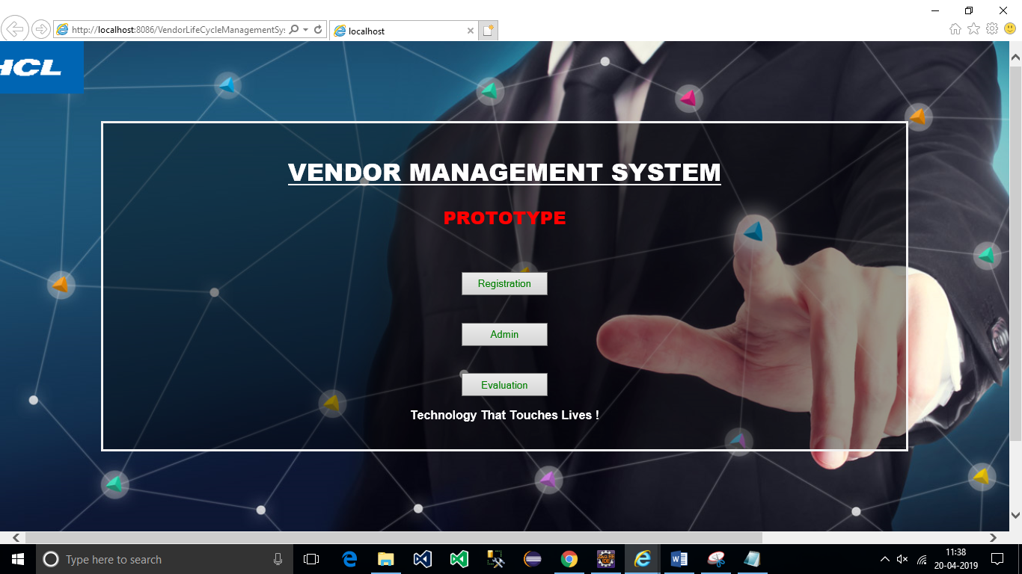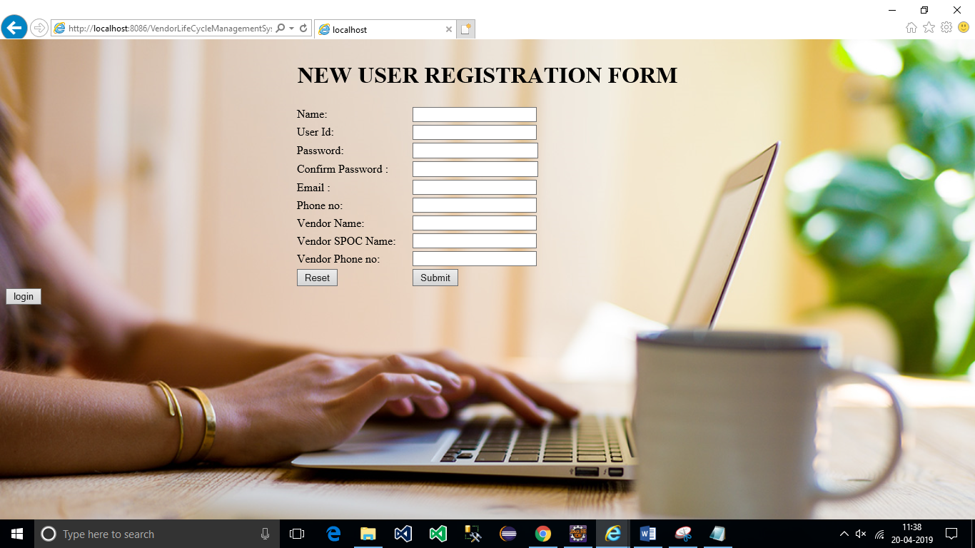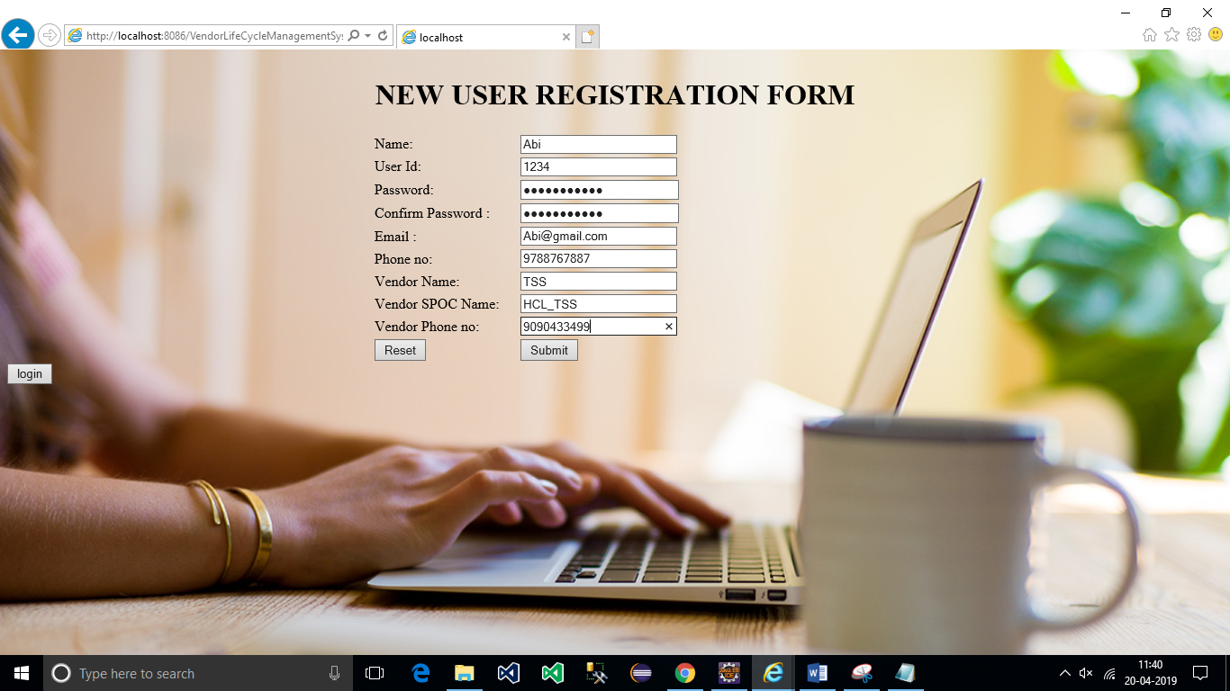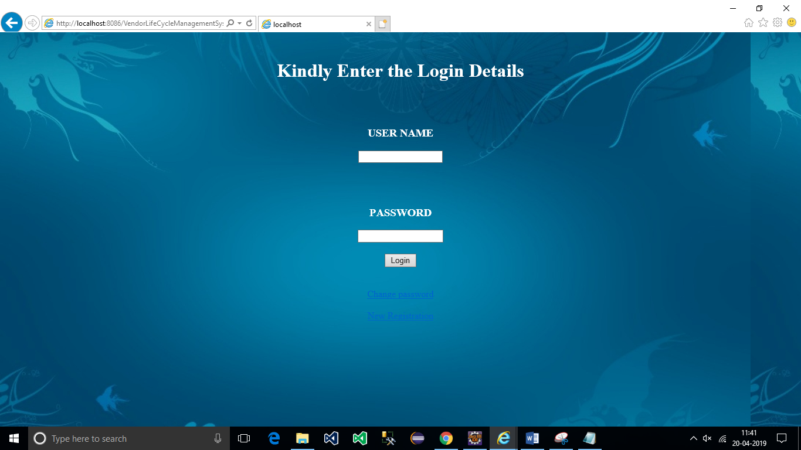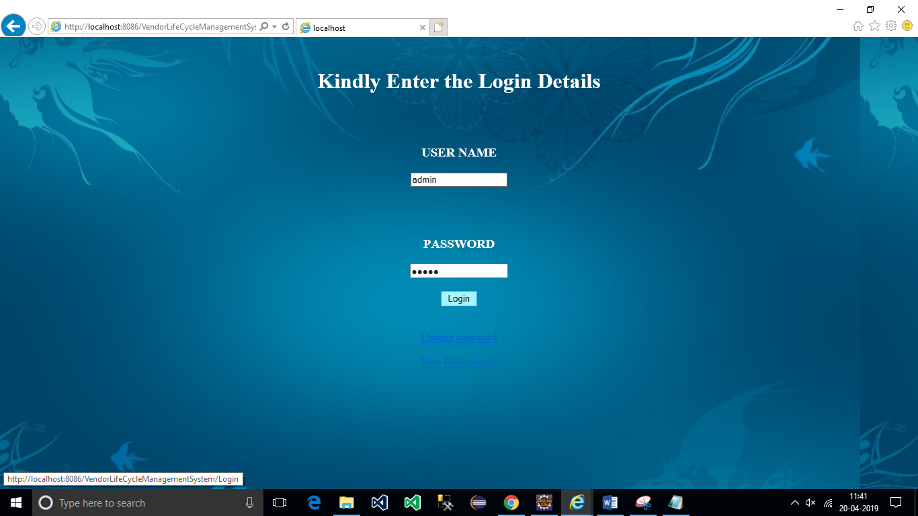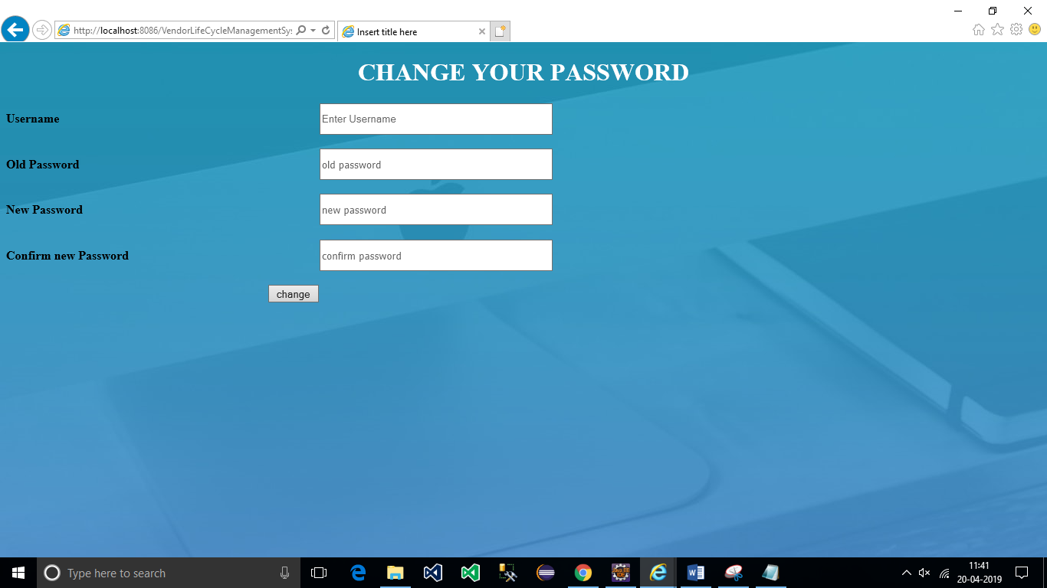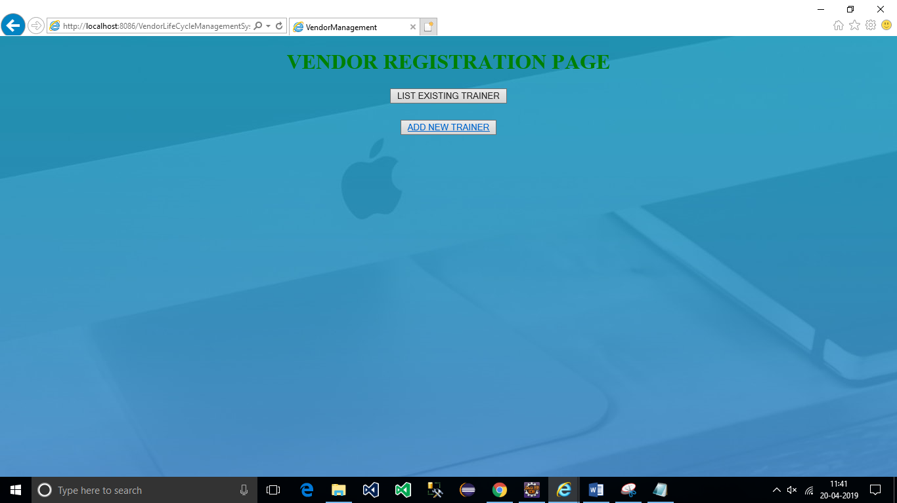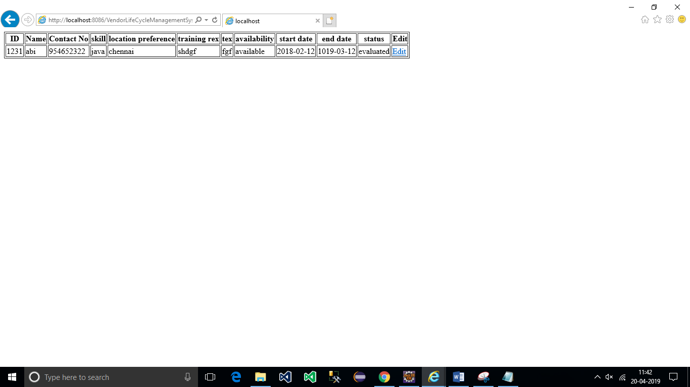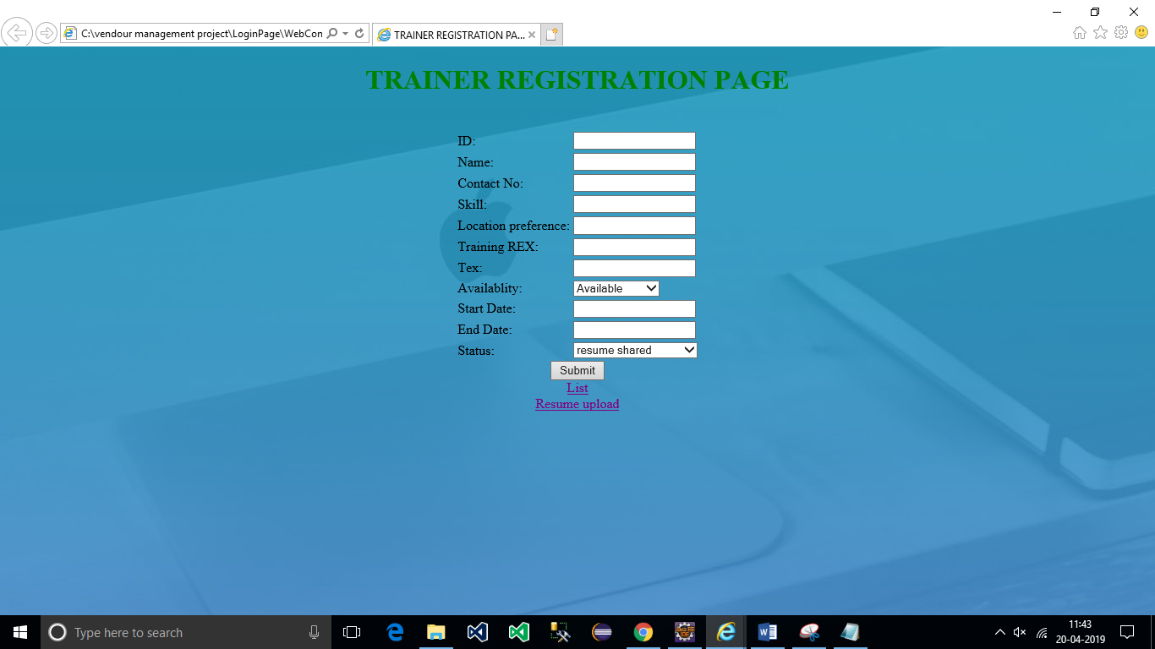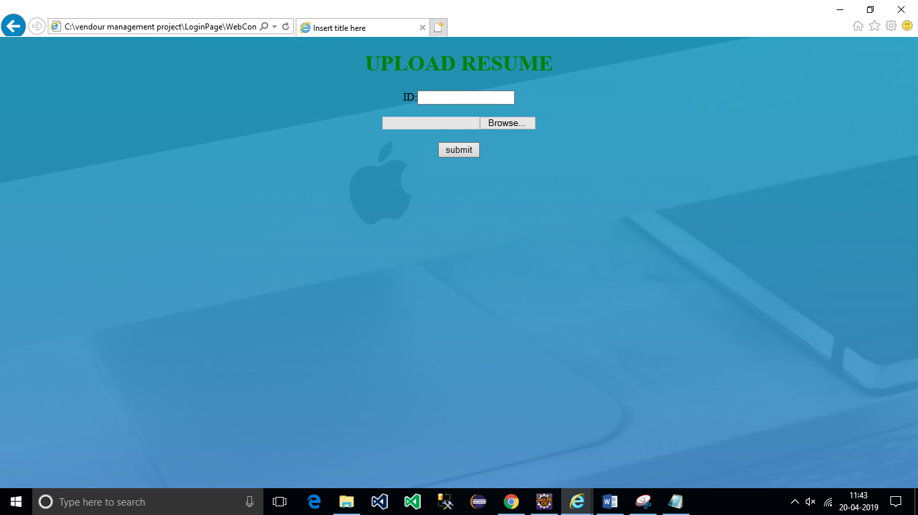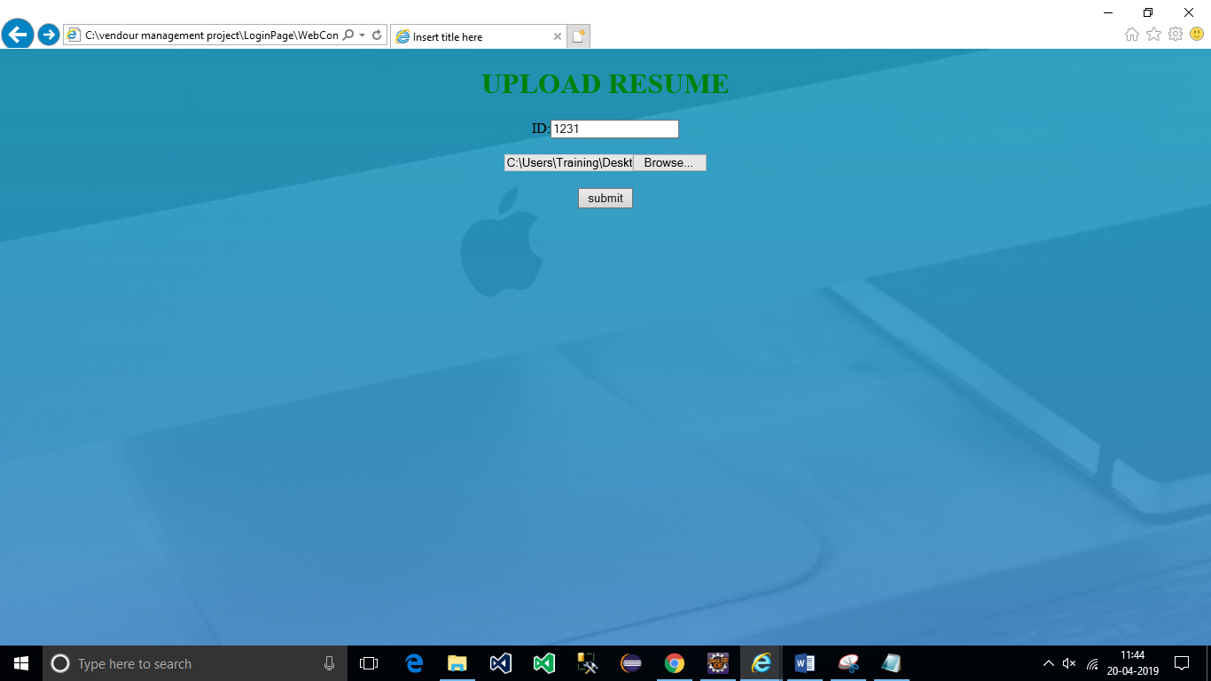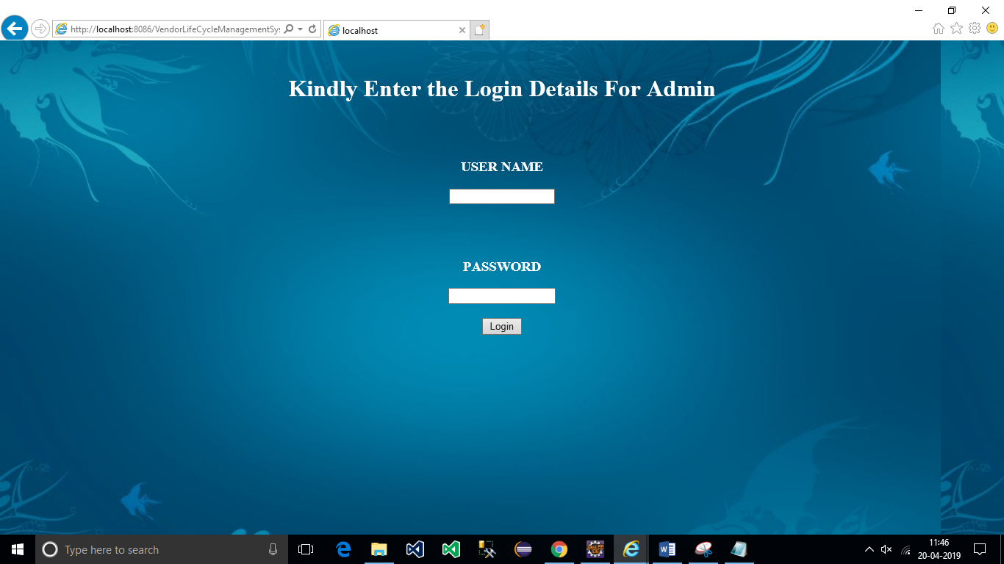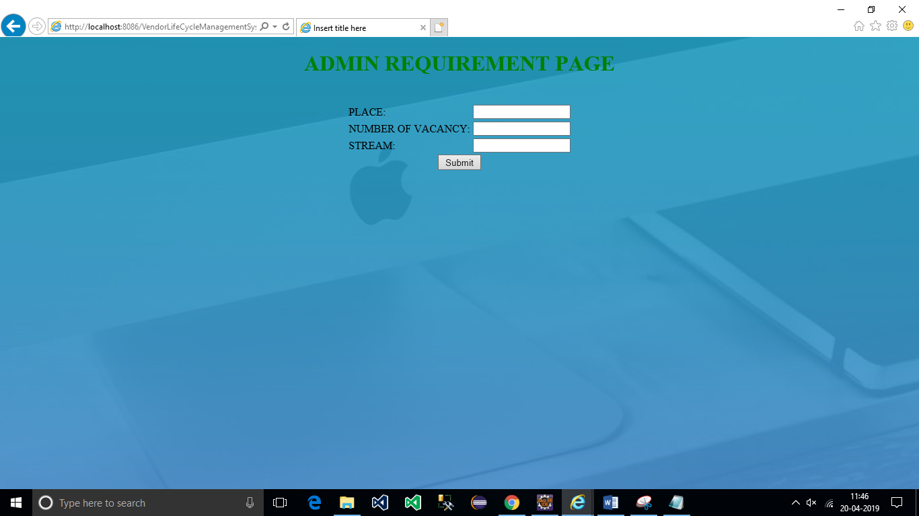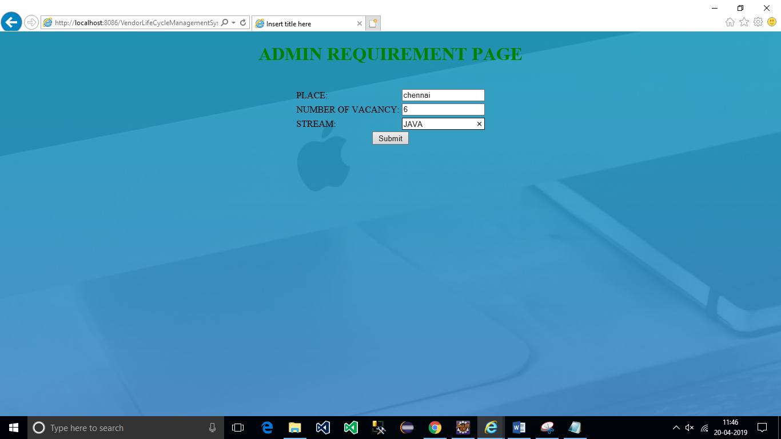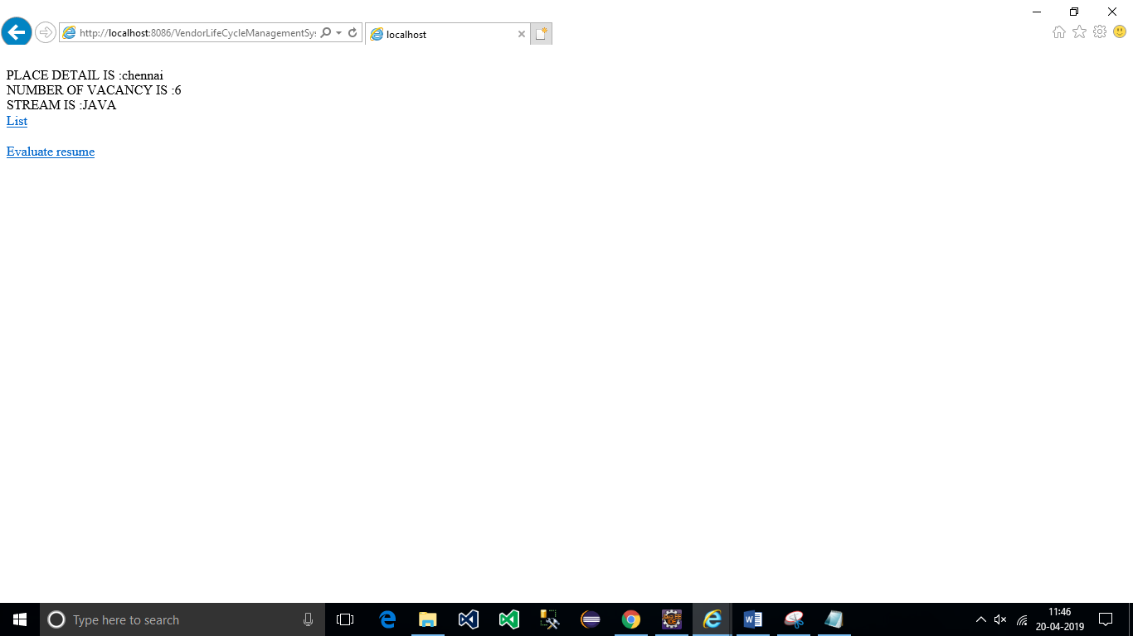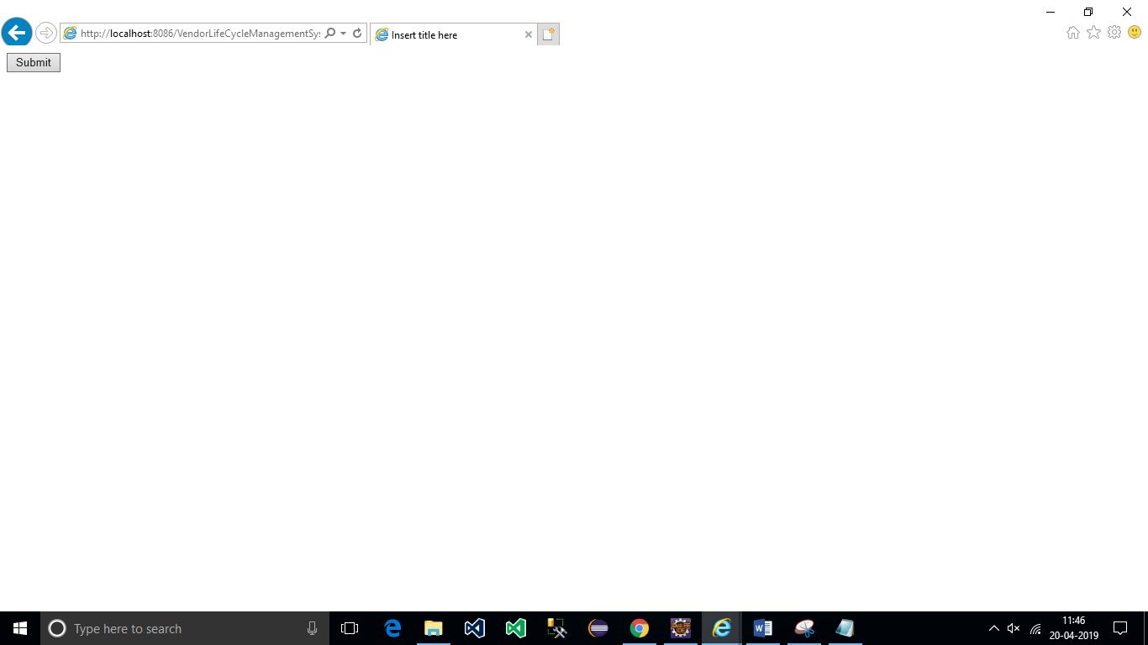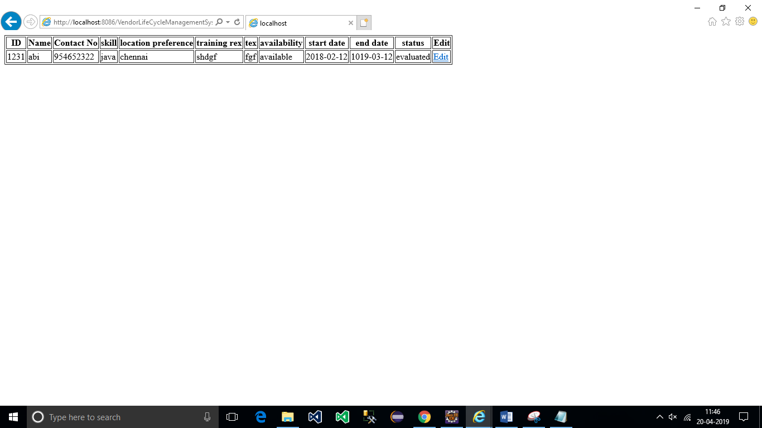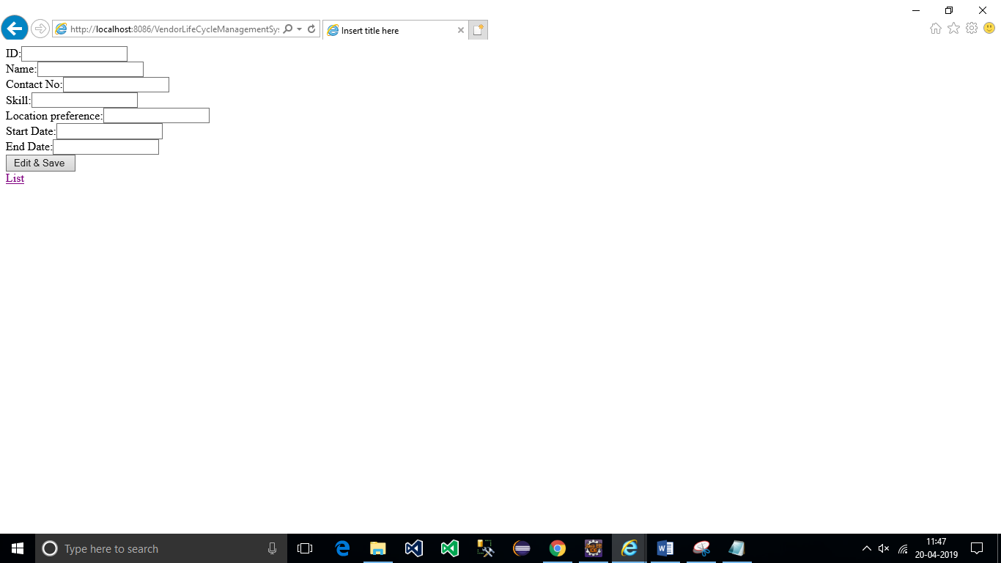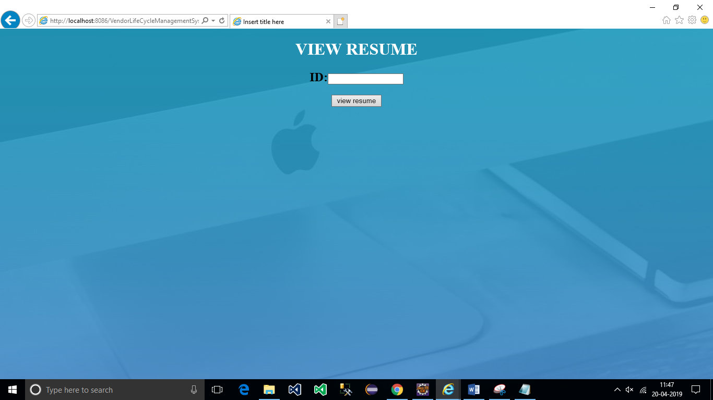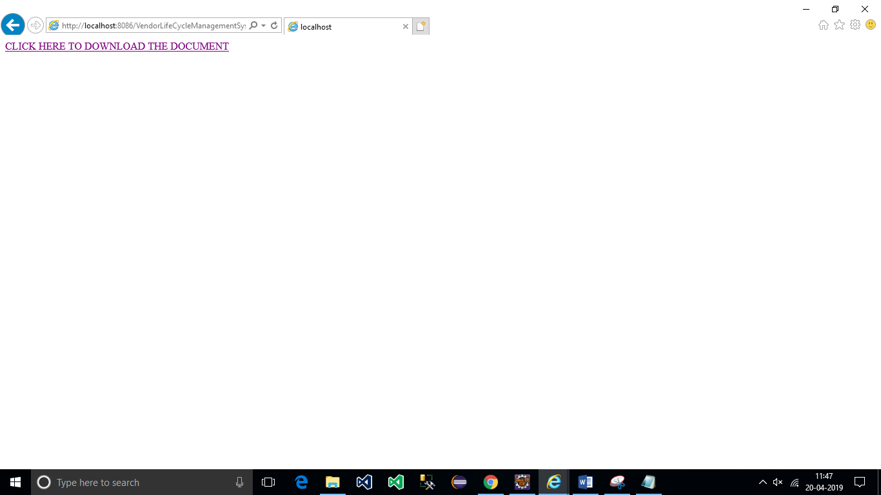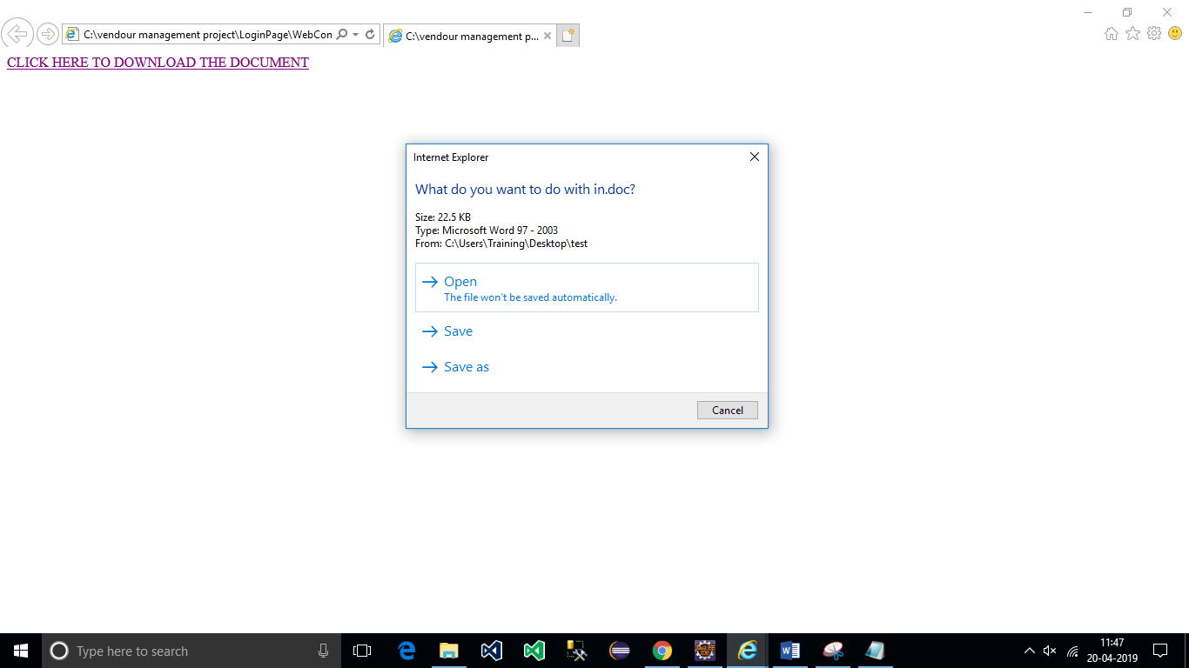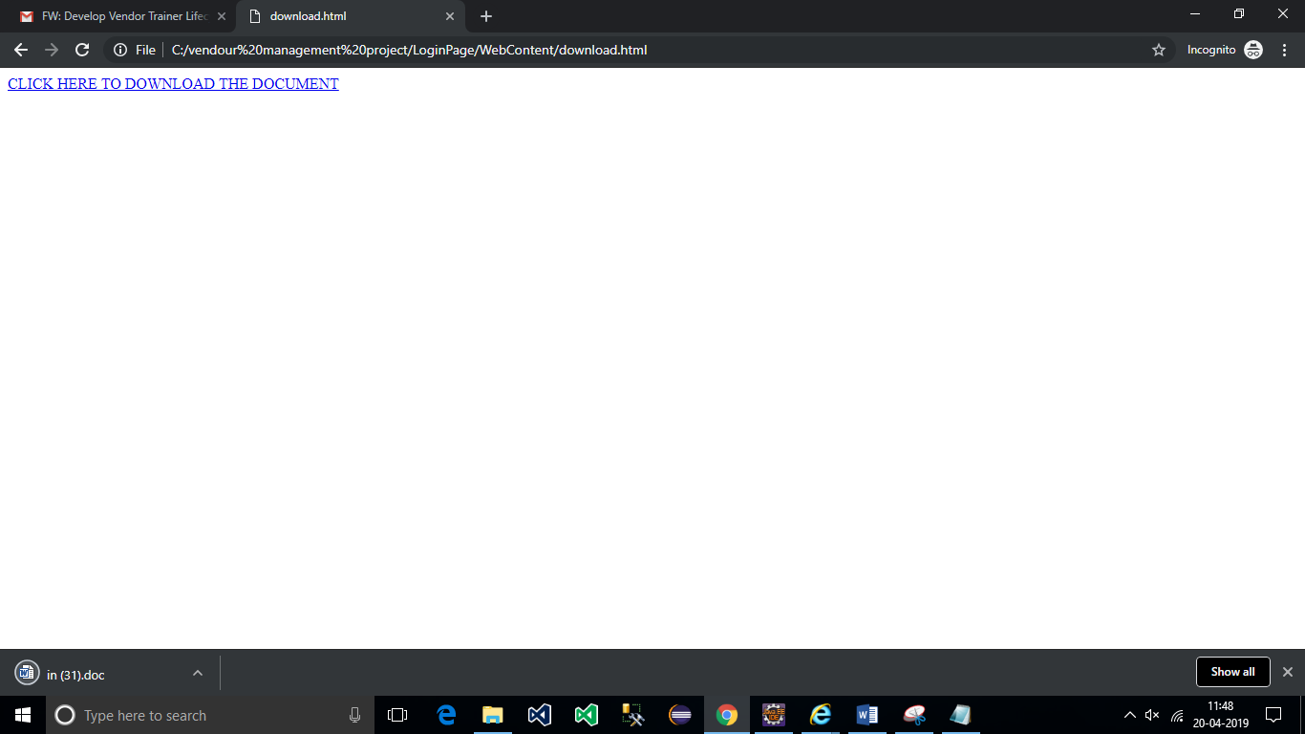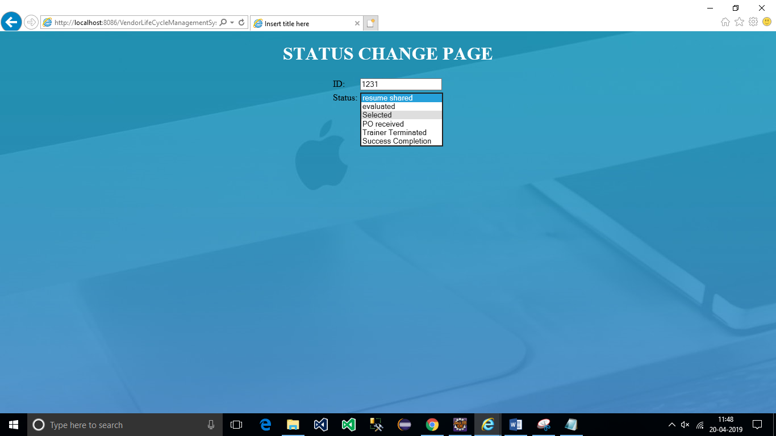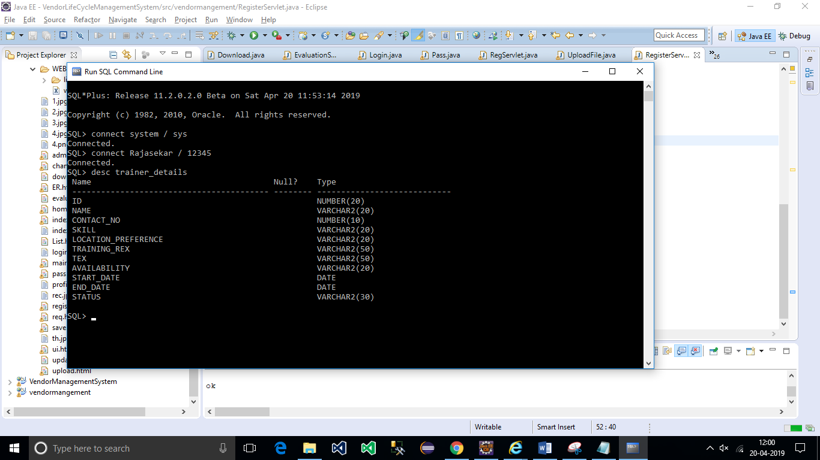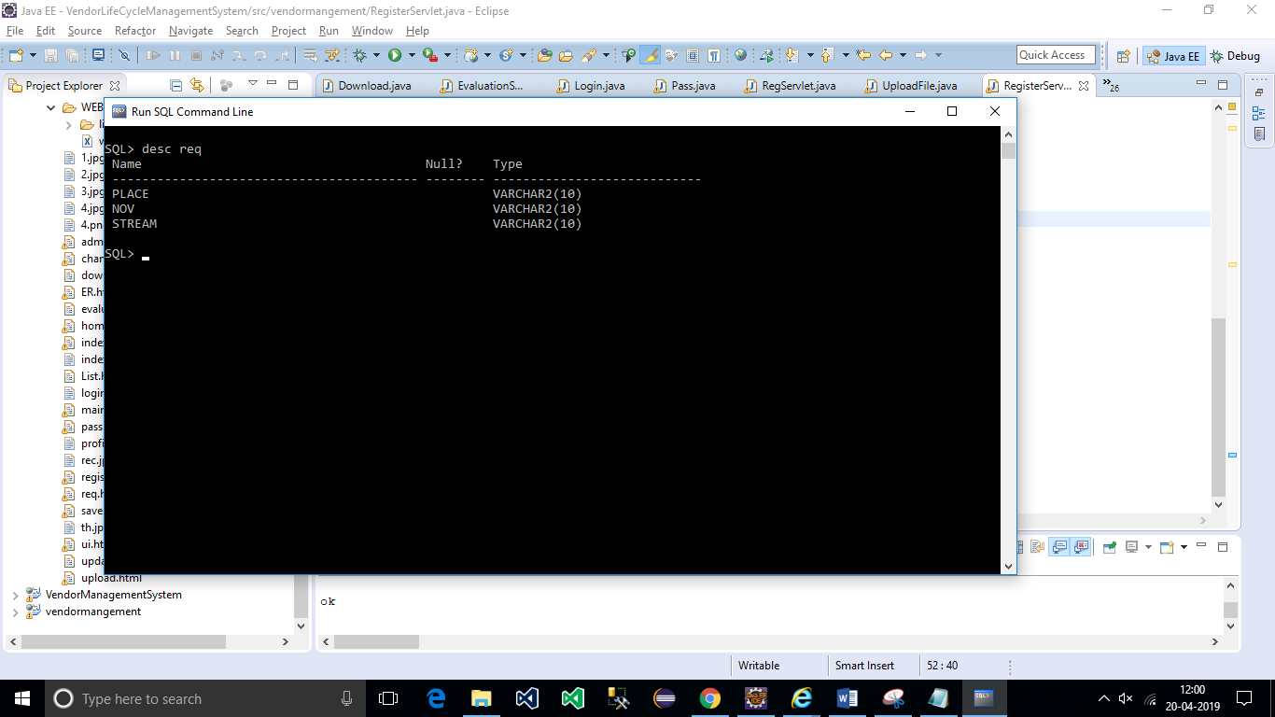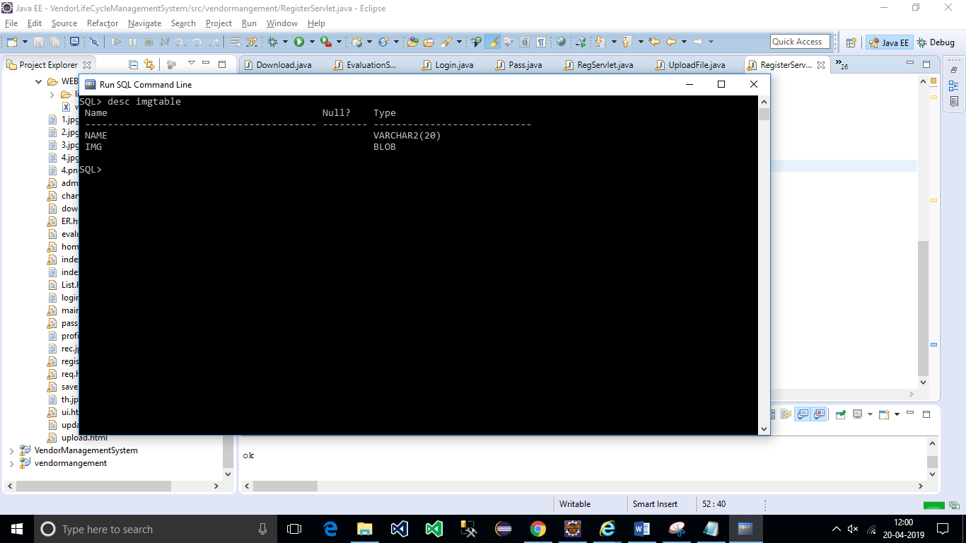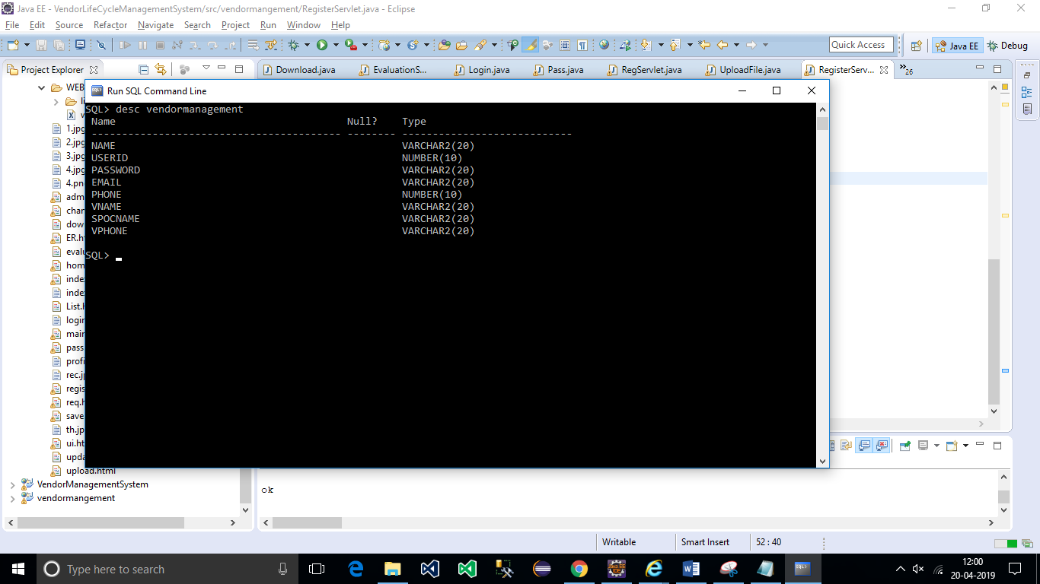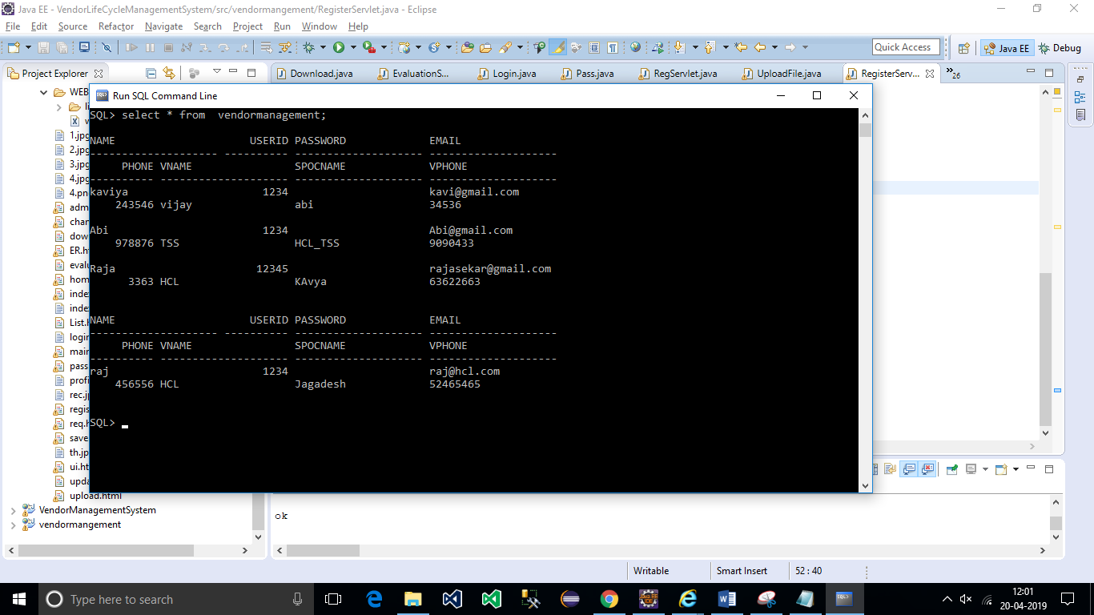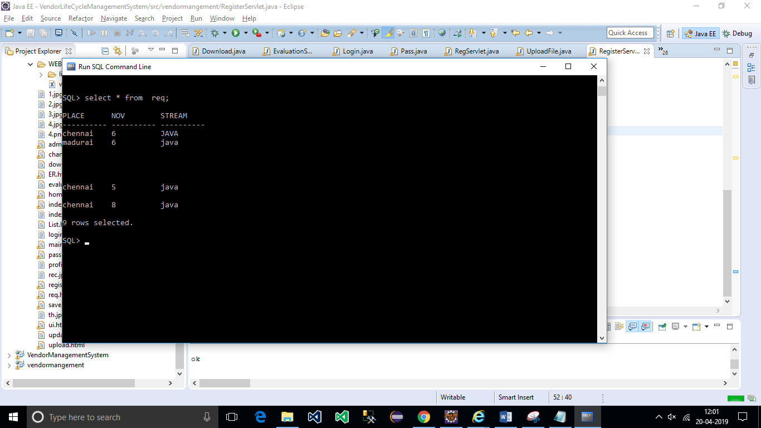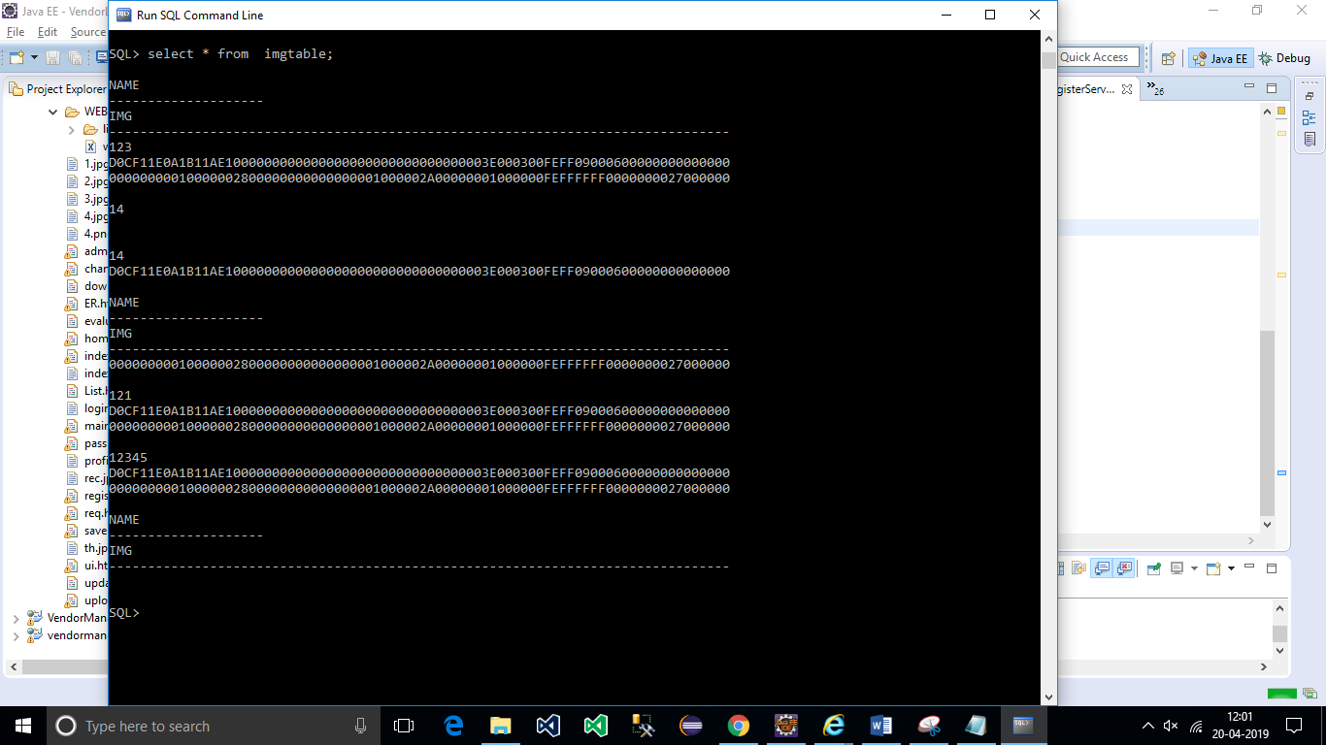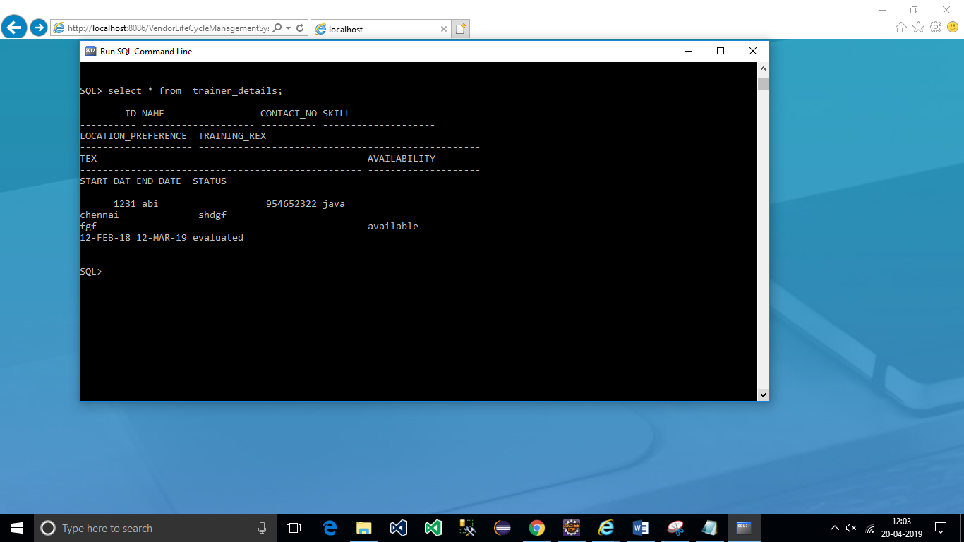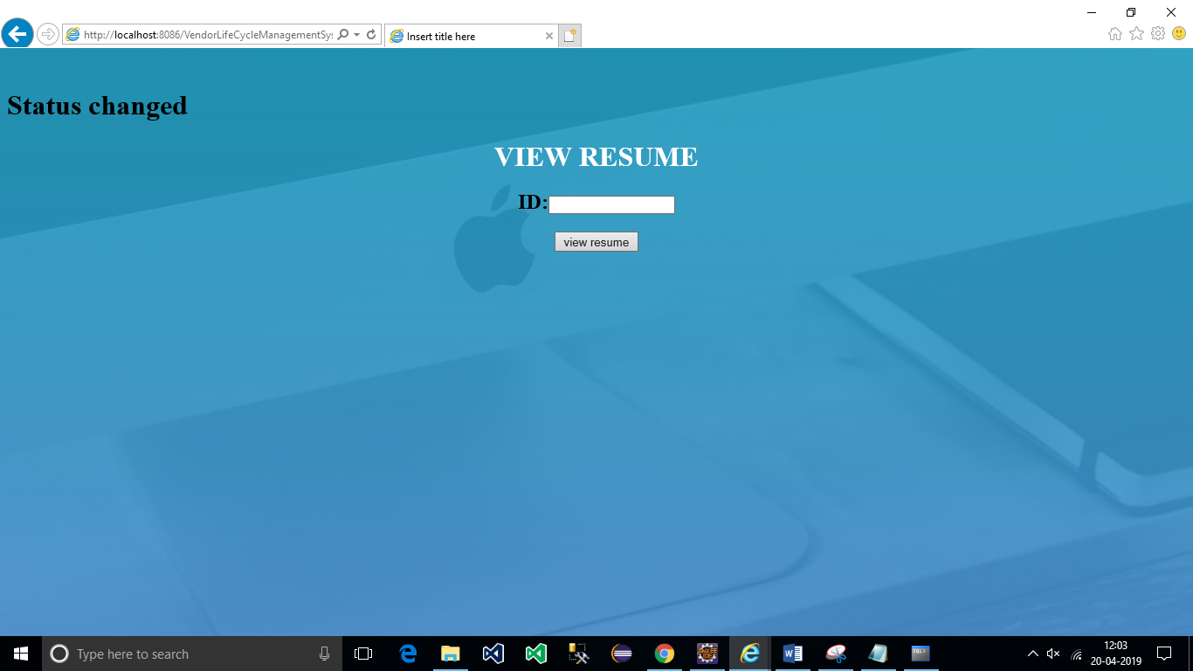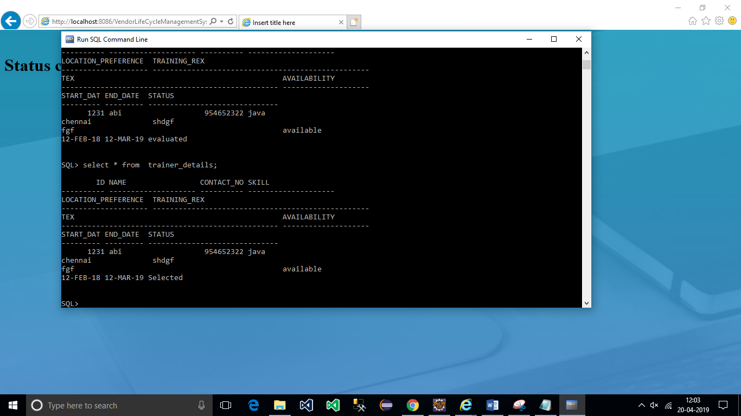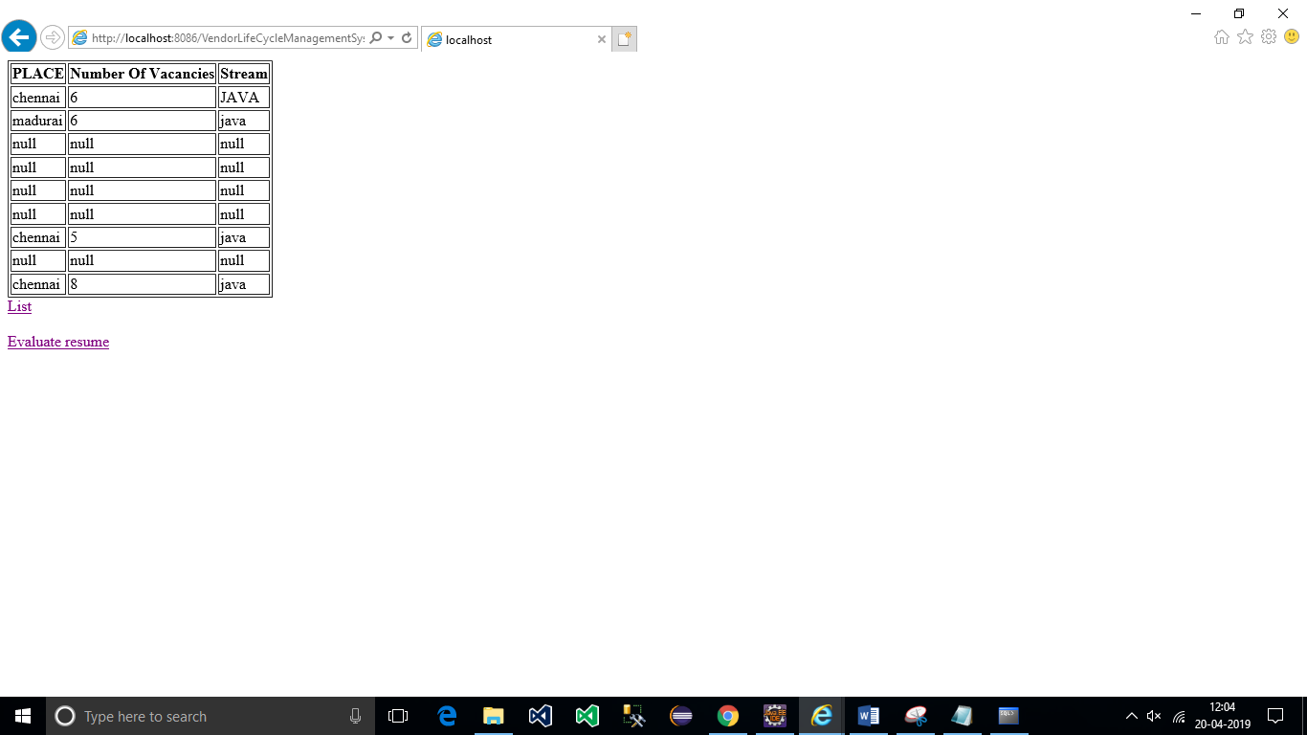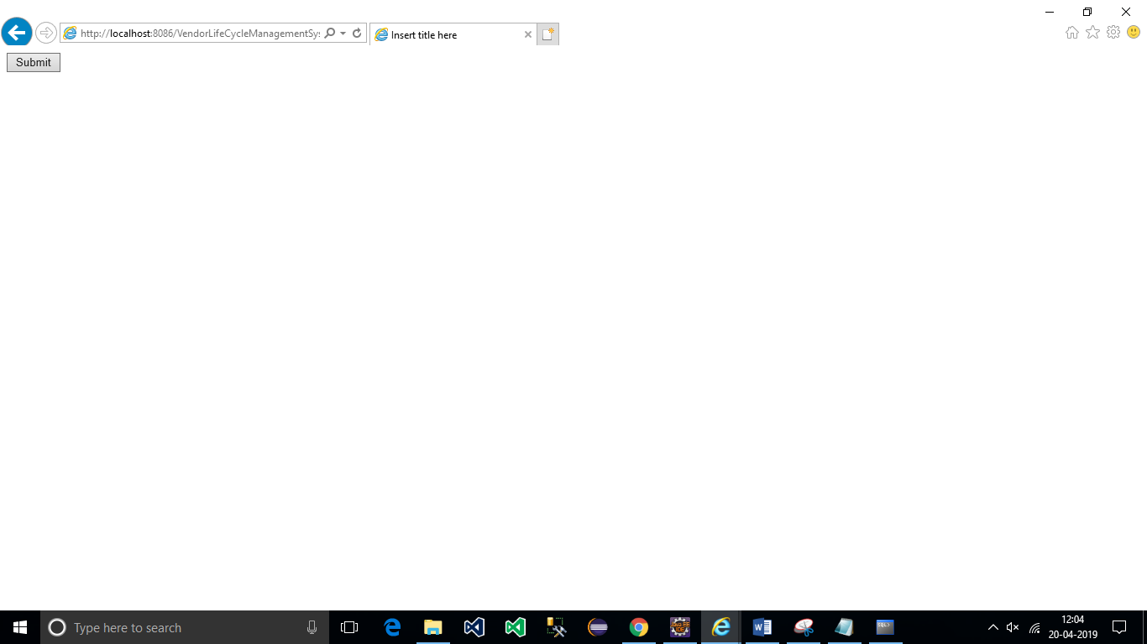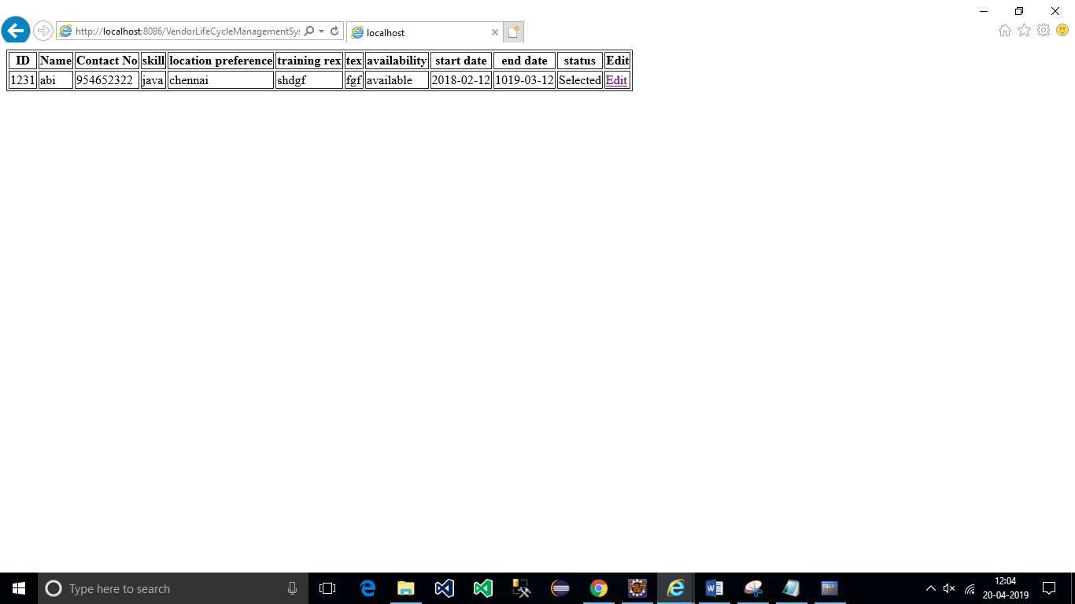

**Further Enhancement:-**

The project explores for single user and it can be enhanced for handling multiple user.

**Developed and Tested by,**

Anitha L.

Dharani K R.

Dhivya R.

Indra M.

Iniyavan M.

Iswarya S.

Joe Mathew J.

Kaviya N.

Kiruthiga R.

Padma Priya V.

Poonguzhali K.

Prasanna B.

Rajasekar K P.

Sangeetha S.

Sridar B.

Sriram D.

Varsha G.

Yougesh J.